Table of Contents
Introduction to the Toolkit 3
Who is this guide for? 3
How to use the Toolkit 3
Theoretical Framework 10
Healing Classrooms: Creating a safe and inclusive learning environment 10
Plurilingual speaker in an intercultural context 13
Language education 14
Facilitating factors for language acquisition 15
Check list: How do I feel? What have I learnt? 22
Module 1 – Personal Presentation 25
Module 2 – Food and drinks 35
Module 5 – Health and emotions 60
Module 6 – City, neighbourhood and leisure time 68

DISCLAIMER:
Co-funded by the European Union. Views and opinions expressed are however those of the author(s) only and do not necessarily reflect those of the European Union or the Asylum, Migration and Integration Fund (AMIF). Neither the European Union nor the granting authority can be held responsible for them.

Introduction to the Toolkit
Welcome to the Theory of Change – XX Toolkit for language learning! The Toolkit is produced by the International Rescue Committee (IRC) in the framework of the "Theory of Change: the use of the art of Rhetoric Speech as an innovative tool" (ToC) project. ToC It is co-funded by the Asylum, Migration and Integration Fund (AMIF) of the European Commission (101141204). The project is intended to address the challenges faced by migrant children in integrating into host societies, particularly focusing on education and language learning. It aligns with European Commission initiatives and the EU Strategy on the Rights of the Child, emphasizing the rights of all children, regardless of their background.

Who is this guide for?
The Toolkit contains a set of activities, guidelines, tips and good practices designed for L2 (second language) teachers, educators and social workers who are involved in facilitating the education and social and linguistic inclusion of children and adolescents with a migration background. The activities are designed for children between 11 and 13, and between 14 and 18. With a focus on those who have recently arrived in the new host country and with a language level from CEFR (Common European Framework of Reference for Languages) for level PREA1 and CEFR level A2. They specifically target students who are literate in their home languages, which means that the students who will use them can read and write in one or more first languages (L1).

How to use the Toolkit
The Toolkit is not a second language manual but a set of activities that can be included in a second language teaching pathway, course or workshops, in formal, non-formal or informal contexts. These activities are designed to complement language courses as standard L2 according to different language domains, contexts and objectives.
Structure of the Toolkit
The Toolkit includes an initial theoretical framework, and six thematic modules linked to six linguistic domains (Personal presentation; School; Food and drinks; Clothes and main accessories; Health and emotions; City, neighborhood, leisure time). You will find the following symbols to support you navigating the Toolkit, receiving tips and understanding what kind of materials or space you will need for an activity.


Theoretical framework
Game Bank



Activities guidelines
Methodological tips

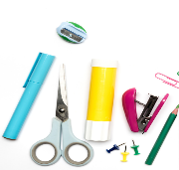
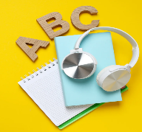
Materials
Language acquisition tips

In the different modules you can find the symbol indicating “expansion”: indeed, the Toolkit is also complemented by a Game Bank which contains more ice-breakers, socialization and practical activities linked to the six linguistic domains. For example, in the Toolkit there are language activities and exercises to be carried out individually, in pairs or in groups. For each language domain, there are also games, play activities, reality tasks and outdoor activities. These activities can be found in the Game Bank and are indicated in the Toolkit with the specific symbol.
The Toolkit is designed based on the CEFR descriptors indicated below and it follows a linguistic progression, starting with self-presentation and basic greeting formulas, and continuing with lexical expansions, formulas for expressing personal needs or wishes, and daily routines of children or adolescents. While it is recommended to use the activities according to the order indicated in the Toolkit (e.g. starting with personal presentation, expanding to colours, clothes, days of the week and school routines), it is possible to use each activity and readapt it to the specific needs of different groups of learners even in a different order than suggested. In the latter case, it is crucial to ensure that all students have the necessary pre-requisites to be able to do the planned activities or suggested games. It is recommended to consult an expert in second language teaching for any doubts, requests for clarification or need to expand the activities.
The Toolkit targets language learning at CEFR level A1, as this represents students' initial engagement with the language. Recognizing the diversity within classes or groups of learners, the material is stratified to accommodate varying proficiency levels. It includes activities designed for both higher-level learners (CEFR level A2) and those at a lower level (CEFR level PRE-A1). To differentiate, specific symbols are used to mark activities of simpler or more advanced levels. Below are the symbols used to denote the various levels:

Activities for students at the A2 level

Activities for students at the A1 level

Activities for students at the PreA1 level

If there is no diversification of levels, it means that the activity is multilevel, i.e. suitable for PreA1, A1 and A2 students.

When selecting the CEFR descriptors for A1 level activities, the focus was placed on oral comprehension and oral production, as these are essential first steps in language acquisition. Emphasis is also given to building vocabulary. Additionally, a smaller portion of the material addresses reading comprehension, writing, and written production, incorporating elements of social media and digital technologies. The "Methodological Tips" symbol will highlight proposals for further exploration in the methodological field, offering guidance on how to adapt the activity for heterogeneous groups, address sensitive topics, or delve deeper into aspects of interculturality.
At the end of each language module, a box with the symbol "Language
acquisition tips" will suggest possible grammatical insights based on the
topics covered in the module.

How can I assess my students and know if they are doing well or what they need?

At the end of the theoretical part of the toolkit, there is also an indication of how to include self-assessment checklists after a language module, such as, language games or activities to evaluate the student's understanding, what they liked or disliked and what they might need to revise or repeat.
The theoretical part ends with a presentation of the chosen CEFR levels on which the language activities proposed in the toolkit are based.

Adaptation process
Each activity should be adapted to the students’ interests, needs, and backgrounds, considering their sociolinguistic and sociocultural contexts, the diversity of settings, gender perspectives, and the varied composition of the group. The activities are designed for children between 11 and 13, and between 14 and 18. Depending on the different activities and exercises, it will be specified if and how they can be modified according to age group or context.
When readapting materials and activities, it is fundamental to consider the following guidelines:
- Evaluate the most suitable way to approach linguistic, cultural, and gender diversity, ensuring inclusive practices for all learners, including those with disabilities.
All images, audio and video files included in the Toolkit and the Game Bank are free of copyright. You can either use those or find others more adapted to your groups of learners and to your context.
- Give voice and space to students’ experiences, languages, cultures, gender identities, and specific needs, recognizing diverse perspectives and lived realities.
- Select and adapt each activity to accommodate students’ attitudes, behaviors, learning preferences, and potential disabilities, employing differentiated instruction where necessary.
- Provide space for various forms of expression, including artistic and creative productions.
- Respect the individual learning pace of each student and prioritize orality and listening comprehension without pressuring students into verbal or written production prematurely.
- Enable children to participate through multiple modalities, such as visual, tactile, or technological means, considering their diverse abilities and preferences.
- Plan with flexibility to adapt to unexpected outcomes and minimize frustration, maintaining a supportive and inclusive learning environment.
- Dedicate time after each activity for collective reflection, encouraging contributions that respect diverse experiences and communication styles.
- Facilitate open discussions about fears, criticisms, doubts, strengths, and positive aspects, integrating gender perspectives and disability considerations into these conversations. Share insights and strategies with colleagues and the broader educational community to promote an inclusive approach.
In the Toolkit, special attention is given to the appreciation of the different languages of origin and cultures of all participants involved in the activities, such as students or teachers. According to the indications of the European Framework for Plural Approaches (CARAP) activities do also aim at developing critical thinking, empathy, active listening and the recognition of diversity as a value. Therefore, the activities in the Toolkit are designed to foster the implementation of all language and culture varieties and to encourage the participation of all possible stakeholders in the education process, such as families, schools, cultural associations.
The activities proposed in the toolkit and game bank are in line with the goals of the 2030 Agenda, in particular Goal 4, quality education, and Goal 10, reducing inequalities. Furthermore, the activities promote some of the Key competences for Lifelong Learning. In particular:
- Multilingualism, Digital and technology-based competences
- Interpersonal skills, and the ability to adopt new competences
- Active citizenship
- Entrepreneurship
- Cultural awareness and expression

Theoretical Framework

This toolkit is focusing on language learning, with a focus on migrant children integrating into host societies. We believe that language is key to integration, participation and inclusion. At the same time, we know that learning is linked to wellbeing, to self-worth, belonging, control. That’s why we decided to use the Healing Classrooms approach as an overarching part of the framework before we look at language learning concept relevant for our target groups.

Healing Classrooms: Creating a safe and inclusive learning environment
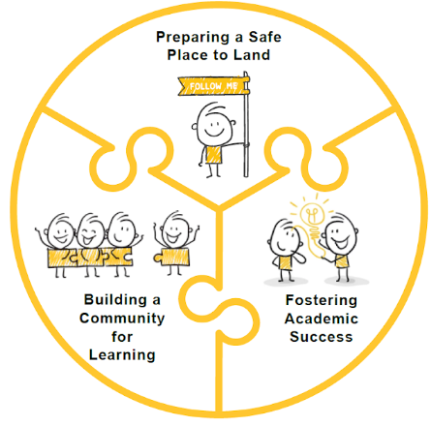
Healing Classrooms are educational environments designed to provide a safe and welcoming atmosphere, crucial for effective and inclusive learning, as well as language development. When students feel safe and supported, they are more motivated to actively participate in learning – educators play a crucial role in facilitating these environments. The primary goal of Healing classrooms is to establish a "safe place to land," fostering not only academic success but also the creation of a learning community that supports students' socio-emotional well-being. In this Toolkit the suggested methodologies provide practical ideas for integrating this approach into school activities, promoting teaching that considers not only academic content but also the emotional and social well-being of students. The intercultural approach, which characterizes the design of all activities, is an essential element of this methodology, ensuring the valuing of each participant's sensitivities and individuality. In this way, Healing classrooms not only promote a more inclusive and welcoming learning environment but also contribute to building a community that enriches the experiences and identities of each individual.
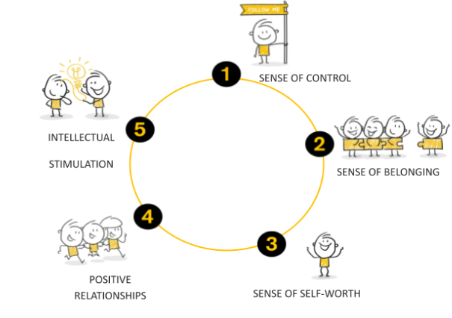
The Healing classrooms approach focuses on five key protective factors that are especially relevant for children and adolescents with migratory backgrounds and in vulnerable situations: sense of control, sense of belonging, sense of self-worth, positive relationships, and intellectual stimulation. These aspects are essential for creating an environment in which students feel valued, develop positive connections with others, and stimulate their intellectual development. Integrating these elements into daily activities helps build effective and inclusive learning environments, where each individual is respected and welcomed. A safe and supportive learning environment is particularly beneficial for vulnerable students, as it promotes their active participation and emotional well-being.

Sense of control
Beliefs of control provide children and youth with a sense of stability and predictability. When students understand what is expected of them and know what to expect from the day, they feel more secure. This is particularly important for children whose daily lives have been disrupted. Studies by the United Nations on the impact of armed conflict on children have shown that fostering a sense of stability has positive effects on children's psychological well-being. A strong sense of control is linked to better physical and emotional well-being, as it helps individuals adapt to adverse circumstances and face challenges with greater motivation, reducing feelings of apathy and despair.
Sense of belonging
The sense of belonging helps children and youth feel included, accepted, and welcomed. Feeling part of a group allows them to build positive relationships with peers and educators, promoting trust, empathy, and constructive interactions. This is particularly important in vulnerable situations, where a sense of belonging enables children to regain self-confidence and develop positive relationships with others. Research has shown that a solid support network is closely linked to emotional well-being, especially after traumatic experiences, as it helps youth cope with stress. A sense of belonging stimulates personal development and self-esteem, fostering greater social participation.
Sense of self - worth
When children and youth develop self-esteem, they feel capable, confident, and proud of their abilities. Self-esteem helps achieve personal goals and positively influence one's life. Traumatic experiences can undermine self-esteem, but a positive educational environment can help young people recognize their abilities and overcome difficulties. Educational professionals can stimulate self-esteem by emphasizing the skills that children and youth already possess, reinforcing their confidence in themselves and their potential.
Positive relationships
Positive relationships are essential for students' well-being. When children and youth establish positive connections with peers and adults, they experience care, emotional support, and recognition. These relationships promote trust, self-esteem, and communication. In particular, for children and youth who have experienced trauma, emotional support from adults is crucial. Supportive relationships with caring adults are key to helping youth overcome challenges and develop a positive outlook on the future.
Intellectual stimulation
Intellectual stimulation helps children and youth develop cognitive skills and reach their full potential. Stimulating activities such as play, sports, painting, or storytelling are fundamental to their neurological and cognitive development. Intellectual stimulation not only fosters cognitive development but also has positive effects on emotional and social well-being. When children are intellectually stimulated, they are more motivated and engaged in learning, leading to better educational outcomes and increased involvement in the learning process.
You will find and identify aspects of Healing Classrooms incorporated in the methods, games and activities throughout the toolkit. E.g. visual aids in learning can provide sense of control and belonging. The “Language acquisition tips” at the end of each module are helpful for fostering intellectual stimulation and self-worth.

The European Framework of Reference for Languages (CEFR)

In order to structure and design the language activities and games in the toolkit and game bank, we decided to use the CEFR descriptors as this is an international document that is recognised across Europe. This document, which is free, available online and constantly updated, provides detailed information about who language learners are, the stages of language acquisition and the different competences and skills a learner should have at the end of each language level.
The CEFR is a document created in 2001, then expanded in 2018 and 2020 that contains clear indications on the profiles of language learners and describes the competencies, skills and activities expected for each language level. It was designed to provide a transparent, coherent and comprehensive basis for the elaboration of language syllabuses and curriculum guidelines, the design of teaching and learning materials, and the assessment of foreign language proficiency (CEFR, 2001).
In the CEFR you can find information starting at the PreA1 level, a fundamental initial step to lay the foundations of the Italian language, to the C2 level, the highest level of mastery in the use of a language and autonomy in communicating in that language.
In some cases, such as for children at preschool, the PreA1 level represents a milestone which can be reached and from which to build and generate more language.
For example, according to the CEFR, a PreA1 student:
- is able to make simple purchases, indicating with the hand or making other gestures to support verbalisation.
- is able to ask the day, time and date and answer the same questions.
- is able to use some elementary forms of greeting.
- is able to say ‘yes’, ‘no’, ‘please’, ‘thank you’, ‘excuse me’.
- is able to fill in uncomplicated forms with personal data, name, address, nationality, marital status.
- can write a short, simple postcard'.

The CEFR’s view of the learner is that of an active agent who uses language in social contexts to achieve communicative purposes and communicates with all the means at his or her disposal. Using all the languages and language varieties known to him or her, gestures and other aspects of non-verbal communication.

Below are the CEFR descriptors for level A1 that we have chosen to use in the activities.
CEFR (European Framework of Reference for Languages) descriptors
Mode of communication | Activity, strategy or competence | Scale | Descriptor
Reception | Oral comprehension | Overall oral comprehension | Can recognise concrete information (e.g. places and times) on familiar topics encountered in everyday life, provided it is delivered slowly and clearly.
Reception | Audio-visual comprehension | Watching TV, film and video | Can recognise familiar words/signs and phrases and identify the topics in headline news summaries and many of the products in advertisements, by exploiting visual information and general knowledge.
Reception | Reading comprehension | Reading for information and argument | Can get an idea of the content of simpler informational material and short, simple descriptions, especially if there is visual support.
Reception | Reading comprehension | Reading as a leisure activity | Can understand short, illustrated narratives about everyday activities described in simple words.
Production | Oral production | Overall oral production | Can produce simple, mainly isolated phrases about people and places.
Production | Oral production | Sustained monologue: describing experience | Can describe themselves, what they do and where they live, simple aspects of their everyday life in a series of simple sentences, using simple words/signs and basic phrases, provided they can prepare in advance.
Production | Written production | Overall written production | Can give information about matters of personal relevance (e.g. likes and dislikes, family, pets) using simple words/signs and basic expressions.
Production | Written production | Overall written production | Can produce simple isolated phrases and sentences.
Production | Written production | Creative writing | Can describe in very simple language what a room looks like.
Interaction | Oral interaction | Overall oral interaction | Can interact in a simple way but communication is totally dependent on repetition at a slower rate, rephrasing and repair. Can ask and answer simple questions, initiate and respond to simple statements in areas of immediate need or on very familiar topics.
Interaction | Oral interaction | Conversation | Can make an introduction and use basic greeting and leave-taking expressions.
Interaction | Oral interaction | Conversation | Can take part in a simple conversation of a basic factual nature on a predictable topic (e.g. their home country, family, school, friends).
Interaction | Oral interaction | Informal discussion (with friends) | Can exchange likes and dislikes for sports, foods, etc., using a limited repertoire of expressions, when addressed clearly, slowly and directly.
Interaction | Online interaction | Online conversation and discussion | Can use formulaic expressions and combinations of simple words/signs to post short positive and negative reactions to simple online postings and their embedded links and media and can respond to further comments with standard expressions of thanks and apology.
Interaction | Online interaction | Goal-oriented online transactions and collaboration | Can complete a very simple online purchase or application, providing basic personal information (e.g. name, e-mail or telephone number).

For further details on the CEFR descriptors and their full version, please refer to official website of the Council of Europe. It is also possible to read the official and specific descriptors of the CEFR for young learners aged 7 to 10 years old and those for young learners aged 11 to 15 years old.

Plurilingual speaker in an intercultural context
In the Toolkit, we have chosen to give value to the multilingual speaker, following European guidelines that value the use of all languages known to a speaker, both in the acquisition of a second or foreign language and in communication in intercultural contexts.
The plurilingual speaker is not seen as the sum of several monolingual speakers, but as an active agent who fluidly uses all the multilingual and intercultural repertoires at his disposal to perform actions with language in different social and cultural contexts.
Emphasizing a multilingual approach to language and communication promotes all aspects of a Healing Classrooms:
- Sense of Control
- Sense of Belonging
- Sense of Self-Worth
- Positive Relationships
- Intellectual Stimulation
A definition of plurilingual speaker can be found in the European Framework of Reference for Languages (CEFR).
This emphasizes a multilingual approach to communication, utilizing all available linguistic resources to fulfil a communicative purpose. Consequently, we need to reconsider the role of language education. In line with the Council of Europe's recommendations, it should focus on the learner as an active social agent within action-oriented methodologies.
In addition, the CEFR highlighted the following aspects when considering language teaching in different multilingual and intercultural contexts:
- languages are interrelated and interconnected, especially at the level of the individual.
- languages and cultures are not kept in separate mental compartments.
- all knowledge and experience of languages contribute to building up communicative competence.
- balanced mastery of different languages is not the goal, but rather the ability (and willingness) to modulate their usage according to the social and communicative situation.
- barriers between languages can be overcome in communication, and different languages can be used purposefully for conveying messages in the same situation.
The importance of being able to value all home languages at school and to consider the multilingual speaker as an asset is also an indication of the European Commission's aim to reduce early school leaving and to provide all students with the same opportunities. In fact, from the perspective of equity, social inclusion and respect for fundamental human rights, the following can be read in a 2017 European Commission report (Rethinking language education and linguistic diversity in schools):
it is therefore essential to ensure that all learners, especially those with less competence in the language of schooling, are supported to develop literacy skills and provided with equal opportunities to thrive alongside their peers. This includes children with a migrant background, bilingual and multilingual learners, but also monolingual ‘native’ learners with low levels of literacy skills. Effective multilingual teaching and learning has the potential to close the achievement gap of migrant students compared to ‘native’ learners, while enhancing the cultural and civic education of all learners.
From the aforementioned documents, we therefore emphasise the importance of promoting equity in teaching, in this specific case second language teaching, both by including the students' languages of origin and their families in the course, whenever possible.
It concludes by recalling that language is transversal to any other school discipline and that, to quote a different European Commission report from 2020, Education begins with language, which includes the involvement of families and the enhancement of each person's multilingual repertoire.

Facilitating factors for language acquisition
Factors that can determine the acquisition of a language are very varied and personal. In addition to various factors such as aptitude, the quality and quantity of input received in the second language, the age from which one is exposed to that language, activities more or less suitable for teaching, specialised and non-specialised teachers or educators, etc., it is also necessary to consider personal motivations for studying the language. Personal motivations are interlinked with family language policies (FLP), i.e. the family's desires, also related to future migration intentions (for example, a family currently residing in Italy may wish their child to learn English instead of Italian because they know that they will try to emigrate to an English-speaking country).
Facilitating factors are also closely related to the environment in which the student is. Clearly, depending on the investment, whether in terms of resources, training of professionals, production of materials and organisation of time at schools to facilitate second language acquisition, the speed, ease and durability of such acquisition will change.
Stages of language acquisition
All these factors have an impact on the question often asked by educators, teachers and language experts: How long does it take for a child or student to acquire a language?
The answer to this question is very complex and the content of this Toolkit would not be sufficient to provide an exhaustive and complete answer. That being said, in an attempt to answer the above question, it is important to take into consideration three key aspects of language learning:
1. The period of silence
2. Basic Interpersonal Communication Skills (BICS)
3. Cognitive Academic Language Proficiency (CALP) skills

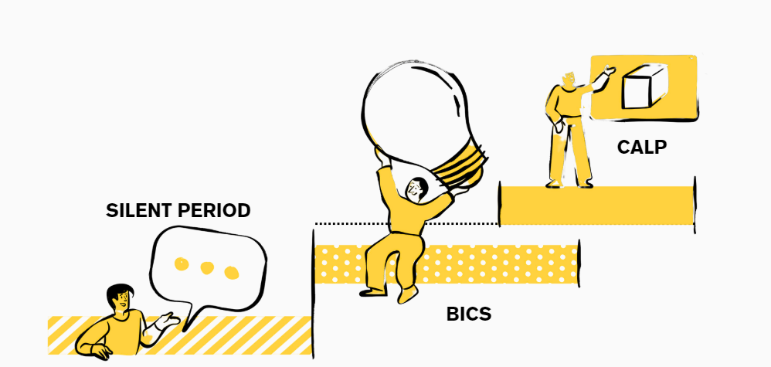
Facilitating language learning with the stages of language acquisition in mind is very much linked to these aspects of a Healing Classrooms:
- Sense of Control – relevant for all phases, but especially during the Silent Period, where establishing a safe space with routines and rituals can be beneficial.
- Sense of Belonging – e.g. during the Silent Period, belonging might be at the lowest and needs fostering.
- Sense of Self-Worth - during the Silent Period, self-worth might be at the lowest and will gradually heighten during BICS and CALP, once fostered.
- Positive Relationships – e.g. during BICS, where students can access their self-worth to link with other students and educators.
- Intellectual Stimulation – e.g. to develop specific learning materials for each stage would foster intellectual stimulation.
Regarding the first point, many teachers or educators are often challenged by the early stages of language acquisition in which they observe silent learners who listen or appear to listen but do not verbally repeat what is said during the lesson. This “silent period” is crucial for language acquisition, in which a child or learner approaches a language, and can last for entire months.
distributed through a synthesis of close observation, intense listening and most significantly copying the practices of others. Throughout the silent period the children are not only seen to be learning but also contributing to the classroom practices (Bligh, 2014, p. ii).
It is for this reason that in the Toolkit we recommend starting with activities that work on listening comprehension and also offer the possibility for those who are not yet autonomous second language speakers to take part in classroom and educational activities through games, multisensory and non-verbal activities, multimodal with differentiated and stratified exercises (see in the Toolkit the proposals of activities in different levels, from PreA1 to A2). The silence period must therefore be respected, verifying the comprehension of the newly acquired information, without forcing repetition or oral production.
With regard to the second and third key aspects: While formal education generally supports the importance of both Basic Interpersonal Communication Skills (BICS) and cognitive and academic language acquisition (CALP), it does not always put students in a position to proceed gradually in their language acquisition journey. On the contrary, it increasingly pushes students to learn in parallel both aspects of the basic language of everyday communication linked to the sphere of personal experience and aspects of the various school subjects. Each step, however, has specific acquisition times.
For BICS, scientific studies speak of about 1 to 2 years.
For CALP, 5 to 7 years of study is usually mentioned. CALP includes not only subject-specific vocabulary but also abstraction, summarising, narrating, putting information in a logical-chronological order, solving a mathematical problem, as well as specific working methods for each school discipline, which may vary from country to country.
Hence the need to guide our students along a gradual path, starting with the language of communication and only then arriving at the language of study of the various disciplines.

Plurilingualism as a universal resource
Surface level L1 L2

Common
Underlying
Proficiency
Central Operating System

cfrefre
s

It is also interesting to consider the iceberg model of Cummins (1980) in which language 1 of a learner, i.e. the mother tongue, and language 2, i.e. the second language, are depicted with an iceberg. Below is an image taken from, simplified and readapted from Cummins' (1980, p. 36) “Dual Iceberg” model.

According to Cummins' model, while on the surface, as can be seen from the figure, the two languages are separated from each other, especially at the lexical level, they instead have a common substratum that holds them together. The substratum is referred to by Cummins as ‘one integrated source of thought’ (Baker, 1996, p.147 in Bligh, 2014) because at the base the cognitive and linguistic, metacognitive and metalinguistic spheres are common. Learning in one language transfer to all other known languages. If we learn to recount an event in the past tense or to summarise in our mother tongue, we will be able to transfer that skill to a second language as well. This passage is facilitated if teachers do not prevent students from being able to use their mother tongue or any other vehicular language during class lessons, even during second language lessons.

For these reasons, it is essential in the classroom to preserve and enhance all the languages spoken by the students and to allow them to also work with languages other than their mother tongue or second language.
- For example, in groups, they can do a summary or role play in English and then translate it together into the second language. To better memorise content, they can make a multilingual glossary or take notes in a more familiar language or in a mix of languages, in a linguistic continuum that characterises today's plurilingual and pluricultural speaker (see CEFR reference framework).
In order not to trivialise and oversimplify specific methodologies that favour the use of multiple languages in the classroom, we refer to the translanguaging approach in Garcìa and Li Wei's volume (2014).
Finally, working in a multilingual context through one's mother tongue or other known languages facilitates academic success and the acquisition of concepts, skills and competences:
Research shows that education in the mother tongue is a key factor for inclusion and quality learning, and it also improves learning outcomes and academic performance. This is crucial, especially in primary school to avoid knowledge gaps and increase the speed of learning and comprehension. And most importantly, multilingual education based on the mother tongue empowers all learners to fully take part in society. It fosters mutual understanding and respect for one another and helps preserve the wealth of cultural and traditional heritage that is embedded in every language around the world. (UNESCO, YEAR)

Play-based activities, orality and authentic tasks

In order to favour activities based on vocabulary and orality, we have chosen to base language acquisition on a playful methodology, which is very much linked to Intellectual Stimulation and Positive Relationships in a HC. According to Krashen (1981, among others) with his Language Acquisition Theory, it is in cognitively and linguistically motivating, calm, interesting, emotionally engaging environments that learners feel most engaged, can have fun and “forget”, as the scholar explains in his ‘rule of forgetfulness’ that they are acquiring language when they are perhaps playing a game of Domino or Bingo.
Furthermore, teaching that puts the learner at the centre is key; to make them feel good and involves them in authentic and realistic tasks in a playful manner is especially crucial for adolescents. According to Harmer (2015), in fact, a successful ingredient for a lesson for students between the ages of 14 and 18 is to make the activities motivating and relevant to them and their lives. Even though some of them may not feel like or believe in the importance of acquiring a language, facilitating activities relevant to their everyday life can actively engage them and facilitate the acquisition process itself. This undermines the importance of including the students by providing cognitively challenging tasks that develop critical thinking, abstract thinking and authentic involvement (see, for example, our proposal to design a multilingual city podcast).

Check list: How do I feel? What have I learnt?

At the beginning and at the end of every subject or teaching activity it is important to know how our students feel, are they tired? Are they angry? Are they happy?
In addition to their emotions, it is also important to know how they feel about language content, vocabulary, and skills. Do they feel ready concerning a certain topic? Do they feel they can pronounce a word? Repeat it? Say a whole sentence? Or perhaps they need to do more exercises and would like some homework?
There are several checklists for self-assessment, one of which can be found in the Toolkit for teaching language to adult refugees (Language support to adult refugees), and many use emoticons. Emoticons are not always internationally, interculturally known and relevant to all learners. In some cases, it is better to use symbols or pictures. Ask your students what they prefer, what they understand best, what they would like to use as a self-assessment. Many emoticons may have different interpretations.
You can see 3 options below:
- 1 exit ticket
- 1 self-assessment checklist with emoticons
- 1 self-assessment checklist with photos or pictures.
These are only examples which can be modified according to needs and specific requests.
Method 1: Exit ticket (Dörnyei, 2001) for students who can read and write.
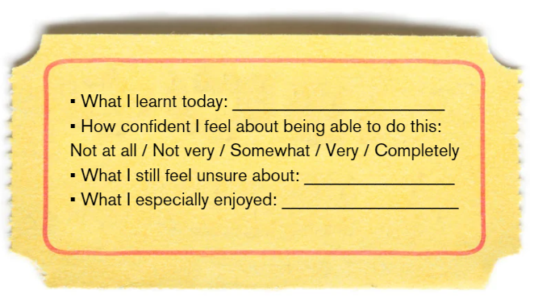

Method 2: Emoticons
Insert the words, the objectives of the lesson, the topics you worked on. For example, for topic 6 it could appear as follows:
How do I feel now? | 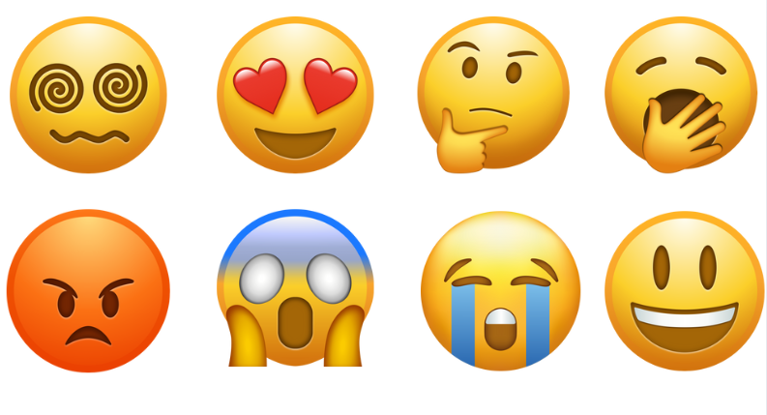
Did I enjoy the multilingual landscape? |  |  | 
Do I know the words we studied about the city?

Do I like working in a group?

Do I like working alone?

Method 3: Photos or pictures and text

How do I feel? |  |  | 
Did I enjoy the multilingual landscape? | Yes, a lot. | Not so much. | No, not at all
Do I know the words we studied about the city? | Yes, a lot. | Not so much. | No, not at all
Do I like working in a group? | Yes, a lot. | Not so much. | No, not at all
Do I like working alone? | Yes, a lot. | Not so much. | No, not at all

Method 4: Percentages
If you have worked with percentages in class, another possibility is to ask the students to explain how much they understood of a topic and how much they did not. For example, I understood 50% or I understood 100%.

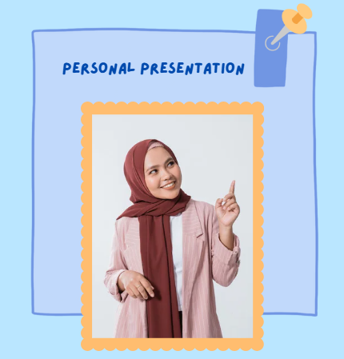
Module 1 – Personal Presentation

Activity index:
Hi, my name is Tom.
What's your name? Where are you from?
Countries and nationalities
Greetings
Let’s count
Telephone numbers and email address
Parts of the body

Content:
Who I am and what my name is.
Where I come from.
Countries and nationalities.
How old I am - How old are you?
Age, phone number, email addresses.
Parts of the day: morning and night.
Greetings and intercultural greetings.
Numbers from 0 to 50.

What do I need?
Scissors
White sheets
Coloured sheets
Pencils
Pens
Blackboard
Pictures and photos as the ones used in the activities
Padlet

ACTIVITY 1 - Hi, my name is Tom.
1a. Introduce yourself by speaking very slowly and clearly. For example, you can say:
Hi, my name is Tom. I am from Germany. I am 41 years old.
You ask the students to say hello, their name, where you are they from and their age. For example: I am Samiful, I am from Afghanistan. I am 17 years old. Ask the same questions to all students: Hi. What is your name? Where are you from? How old are you? Each time a student answers, the teacher writes their name, country of origin and age on the blackboard.
1b. The students then can write their name on a coloured sheet of paper. On another they write their country of origin and on another their age.
 |  | 
Choose three colours. For example, on an orange sheet the students can write their name, on a green sheet their country and on a blue sheet their age. Shuffle the sheets and invite the students to stand up and reconstruct the name, country of origin and age of each participant. The students can look at the board to remember their classmates' names, countries of origin and ages.
If it is not possible to do a movement activity in the classroom and/or if the group is a PreA1 level and at an early level of competency, or if the students are not used to work in the large group, the teacher can divide the students into small groups of 4, for example, and shuffle the cards for the 4 group members only. Together, all 4 students must reconstruct the name, country and age of their group members.
1c. Now ask each student to repeat Hello, What is your name? Where are you from? How old are you? Each student starts asking another student these questions. The student who answered chooses another student and asks the same questions. Guide the students as they formulate the questions.
PreA1 students choose one question, e.g. what is your name?
A1 students choose 2 questions plus the surname and A2 students formulate all 3 questions.
For the 11-13 age group you can use a soft ball and ask the students to gently pass it to another partner to formulate questions.

In these activities, we focus on repeating basic greeting and introduction phrases, as well as key language structures. Repetition is crucial at the beginner level to strengthen language learning and memory retention. To keep practice engaging and avoid boredom, it's important to use a variety of activities while sticking to the same structures until they are mastered. Once these are well-learned, new expressions and phrases can be introduced.
ACTIVITY 2 - What's your name? Where are you from?
A1 students receive a card with a table like the following.
Name | Surname | Country | Age
Students move around the class and write the names of at least 3 classmates, the country they are from and their age.
PreA1 students receive the following table. PreA1 students can work in pairs:
Name | Country | Age

Give A2 students a different table where they can enter information and compare the other students. For example, if there are 5 pupils from Bangladesh, 3 from Ukraine, 4 from Iran, 5 from Burkina Faso, 2 from Colombia and 7 from Greece, the teacher will make a table like this:
Name of students from Bangladesh | Age of students from Greece | Other countries

These table activities also involve movement within the class. If this is not possible, split the class in groups according to levels so that they can complete the tables.
ACTIVITY 3 - Countries and nationalities
Ask the students to match the left-hand side countries with the right-hand side countries and nationalities. Hand out the example.
Senegal | Afghan
Bangladesh | Pakistani
Spain | Bangladeshi
Italy | Greek
Pakistan | Senegalese
Greece | Spanish
Afghanistan | Italian
It is also recommended to add a column with the flags of the nationalities present in the classroom. In this way, students can link the flags, to nations and then to nationalities. You can also build a large poster together to keep in the classroom.
PreA1 students only focus on the main nationalities in the classroom.
ACTIVITY 4 - Greetings at different times of the day.
4.a Show two comics where two individuals greet each other and introduce themselves. They are greeting each other during the day and at night.
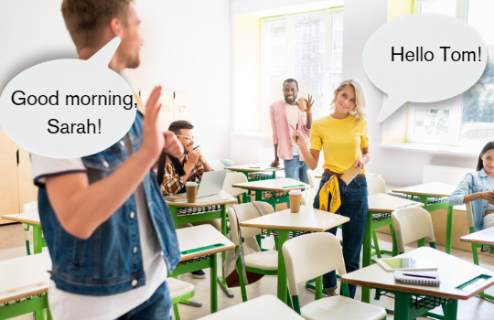

Read out loud the two comics.

Visual memory

4.b Ask the students: what do I say when it is daytime? What do I say when it is night? You can guide students in formulating answers by asking, for example, Do you say 'good morning' or 'good night' during the day? You can support these requests and questions by also showing pictures, one representing a city by day and one representing a city by night.

 | 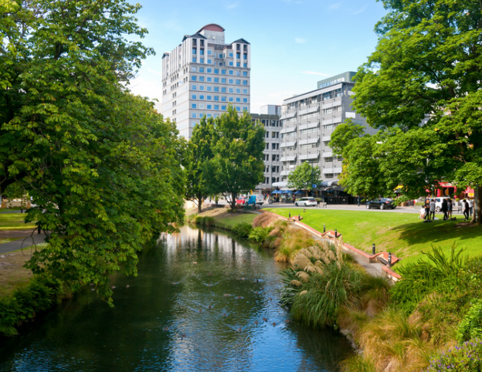
PreA1 students can work on Good morning and Good night without adding any other greetings.
If you work with A2 students, you can introduce greetings such as Good afternoon and Good evening
Ask the students: how do you say Hello, Good morning and Good night in your language or in other languages you know?
It is important to always give the opportunity to use languages other than one's mother tongue because some students may not wish to use their language as soon as they arrive or during their staying in another country.
World map

4.c Give a sheet with several greetings in different languages, for example, French, Bangladeshi etc, and ask if the students know or recognise some of the greetings. Ask if they use them during the day or at night. Use the following picture as an example.
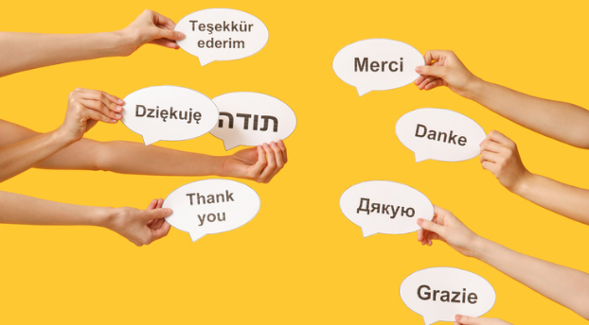
Greeting gestures

ACTIVITY 5 - Let's count
5.a Show the pictures. Ask the students to circle the numbers in green and the words not referring to numbers in red.
তিন
DUE
ΔΕΚΑ
사람
PO
10
TRES
DUE
GIRL
HEJ

عشرة
HOME
男人
8

5.b Show the pictures. Ask the students: What numbers are they and in what language?

 |  | Guide students to research how fingers are counted in other parts of the world. For example, in Chinese and Bangla, fingers are used differently.
In English we count like this:
1: ONE – 2: TWO – 3: THREE – 4: FOUR – 5: FIVE – 6: SIX – 7: SEVEN – 8: EIGHT – 9: NINE – 10: TEN
For an A1 level it is possible to count up to 100, for an A2 even up to 500. It is recommended to work first on numbers up to 20, then on numbers up to 50, then on numbers up to 100. Gradually and slowly introduce new numbers, both written and matched by pictures. In different parts of the world people count with their fingers in different ways.

6. ACTIVITY 6 - Telephone numbers and email addresses
6.a Write on the blackboard: my phone number is, for example, 098 232 245. First, explain the question: What is your telephone number? And then explain the answer: my number is ....
6.b The students are divided into pairs. In each pair there is one student A and one student B. Student A asks student B:
- What is your name?
- What is your surname?
- Where are you from?
- Do you have a mobile phone?
- What is your phone number?
When student A has finished, student B asks the same questions. Then student A tells the class the information he/she has on student B and student B tells the class the information he/she has on student A.
While the students in pairs listen to the other classmates' answers, they have to write down the information they hear to do exercise 11.
Students may use the following table to take notes:
For PreA1
Name
Country
Mobile Phone
Email address
For A1 and A2
What’s your name?
Where are you from?
Do you have a mobile phone? | Yes No
What’s your phone number?
Do you have an email address? | Yes No
What is your email address?

6.b Ask the students the following questions:
How many boys or girls are in the class? How many are Spanish? How many are Turkish? How many are Pakistani? Write down the nationalities you hear. How many students have a telephone number or an email address? Add as many rows to the table as there are nationalities in the class.

HOW MANY? | NUMBER
BOYS
GIRLS
Nationality 1 (for example PAKISTANI) | 11
Nationality 2
Nationality 3
Nationality 4
Students with mobile phone
Students with email address


During or at the end of Module 1, you can expand on:
- Feminine/masculine/gender neutral or third gender if present in the second language of instruction.
- Singular and plural.
- Verbs used to greet and present in the infinitive form, in the present tense and in the manner and tense in which they are usually used at the beginning of a second language course in the languages of interest.
- Adjectives of nationality.
- Parts of the body and gestures.
Many words and names, countries, nationalities, numbers

Module 2 – Food and drinks


Activity index:
Food and drinks
Guess the ingredients
What do you like?
Drinking or eating?
Tom's fridge
In the supermarket
Word-picture matching

Content:
Main food and drinks
Drinking and eating
What I like and what I don't like
Main ingredients of a recipe
Buying food and drink
Preparing a party

What do I need?
- Scissors.
- White sheets.
- Coloured sheets.
- Pencils.
- Pens.
- Blackboard.
- Pictures and photos as the ones used in the activities.
- Real food (see Game Bank).

ACTIVITY 1 – Food and drinks
Show a list of food and drinks. Read and pronounce each word in a highly articulate manner.
For A2 students, when reading, also ask if they know the food or drink.
Rice | Pasta | Pizza
 |  | 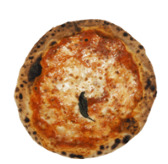
Banana | Apple | Orange
 |  | 
Chicken | Cheese | Eggs
 |  | 
Fish | Salad | Tomato
 |  | 
Couscous | Ice cream | Coffee
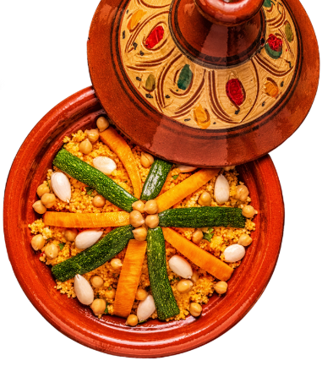 |  | 
Cereals | Yoghurt | Potatoes
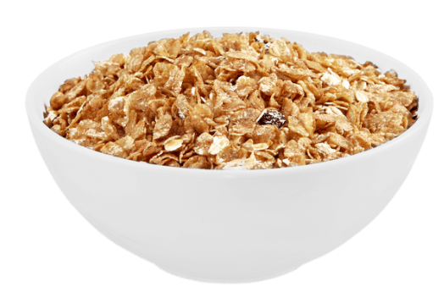 | 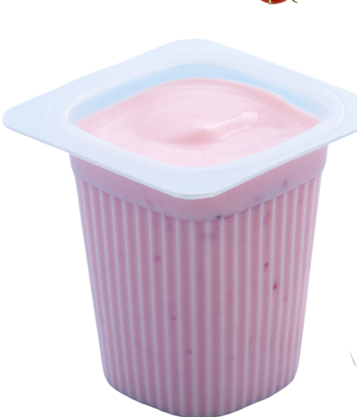 | 
Fruit juice | Milk | Aubergines
 |  | 
Garlic | Onion | Oil
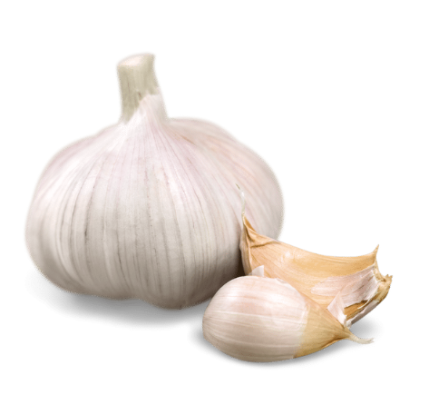 | 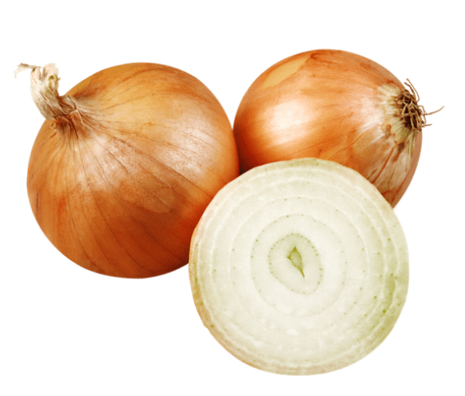 | 
Salt | Sugar | Tea
 |  | 
ACTIVITY 2 - Guess the ingredients
Ask the students to look at the pictures and ask: Which ingredients from the list in the first exercise do you recognise?
PreA1 students can indicate orally what they see or underline the words from the list in exercise 1.
A1 and A2 students can write down the words they see.

 | 
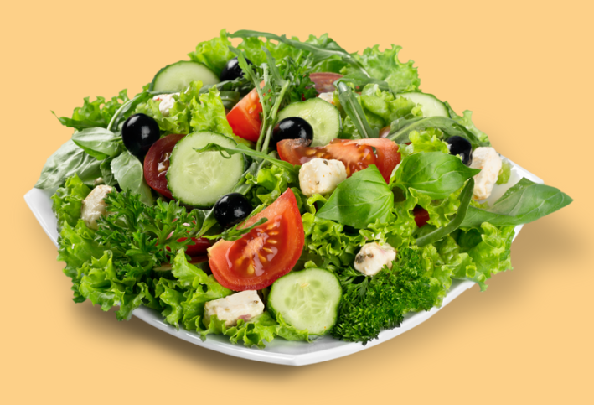 | 

Throughout all activities, we use images of food, places, and people that reflect diverse cultural and social realities. Recipes can be adapted, but we recommend including dishes from around the world, different from those familiar to the students. Just as with language, students may not always want to share their own cultural background through food. To ensure inclusivity, it is important to feature dishes from various nationalities, even those not represented in the classroom.
Cook and take a picture

ACTIVITY 3 – What do you like?
Ask to take the pictures from Exercise 1.
Ask the students: Do you like it?
Explain that they can answer with: Yes, I like it or no, I don't like it. Give examples yourself before letting them answer. Say, for example: I like fish, I don't like coffee.
You can print out the pictures from ACTIVITY 1 and ask the students to paste them on a sheet of paper into two different tables, one for foods they like and one for foods they do not like.
You can also make two boxes in the classroom and ask the students to put the pictures of the foods they like in one box and the foods they dislike in another. At the end you can make a list of the foods that the class likes and the foods that they do not like.
For PreA1: do not force oral production. Students can indicate the foods without repeating them.


A2 students can also write down the names of the foods and help the teachers with questions (e.g. what do you like?).

ACTIVITY 4 – Drinking or eating?
Take the foods from exercise 1 and cut out each image. Ask the students to separate the food you can eat from those you can drink. Give some examples before starting the activity. Each student can have a shopping trolley like the ones seen in the pictures and the food to put in it. In the red trolley they can place the drinks, in the yellow one they can place food. Alternatively, the pictures can be pasted into a table. As in the previous exercise, A2s can also write down the names of the foods, while PreA1s can carry out the activity without forcing oral production.
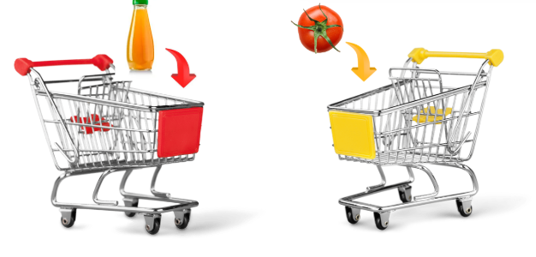

Let's play!
ACTIVITY 5 – Tom’s fridge
Say: Look at Tom's refrigerator. What's in it?
Guide students orally: There is a banana, there are two tomatoes, etc. Then explain to the students that they have to write down the names of the foods they see in the fridge, and they can look at the example.
PreA1 students can only work orally or match foods in the fridge, e.g. banana, with cut-outs from supermarket flyers with real foods. So, a PreA1 student can recognise the banana and match a picture cut out from a flyer of a banana sold in the supermarket.
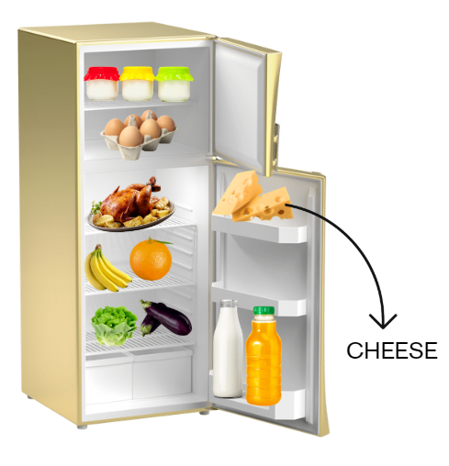
For A1 students, hand over the list of words in the fridge from which they can choose. For A2 students, on the other hand, it is not necessary to provide the correct words.

What's in my fridge?

ACTIVITY 6 – At the supermarket
Divide the class into small groups or pairs. Provide each group with authentic supermarket flyers. Ask each group to cut out food and drinks as if they were shopping at the supermarket. Each group can cut out and paste the materials onto a sheet of paper or a picture of a large shopping trolley.
At the end of the activity, each group should tell the others what they bought. Each group has 50 euros available. They will have to say how much the products cost, how much money they spent and whether there is any money remaining.
Readjust the exercise according to the currency of the different countries.
Make sure that students know the numbers up to fifty and the simple past tense (e.g. we bought). Alternatively, carry out the activity in the present tense (e.g. I buy, or we buy...).

ACTIVIY 7 - Word-picture matching
Ask students to match pictures with words.

1 |  | a | MILK
2 |  | b | RICE
3 |  | c | ORANGE
4 |  | d | BANANA
5 |  | e | TOMATO
1.___ / 2. ___ / 3. ___ /4. ___ / 5. ___
Domino of food and drink
Bingo of food and drink
Eating in the World
Hosting a party
Sensory activities
The pizza recipe

During or at the end of Module 2, you can expand on:
- There is/there are according to the different second languages.
- Singular and plural.
- Regular verbs in the present tense or simple past.
- Numbers.
- I like / I do not like.

Module 3 – At school


Activity index:
What words do you know?
Guess the correct objects
Search for objects
School Spaces
Which subject do you like?
Actions at school

Content:
Main school objects
Main school spaces
Colours
Days of the week
School subjects

What do I need?
- Scissors.
- White sheets.
- Coloured sheets.
- Pencils.
- Pens.
- Blackboard.
- Pictures and photos as the ones used in the activities.

ACTIVITY 1 – What words do you know?
Start the activity by showing pictures of a school bag and a backpack to the students. Ask them which of these objects they have, which ones they use regularly, and how these objects are called in other languages they know. To make the activity more interactive, bring a large backpack filled with various objects to class. Take each item out one by one, showing it to the students, and ask them what it is called. Encourage them to name the objects in their own languages as well. As each object is identified, spell out the word slowly for clarity and write it on the blackboard.

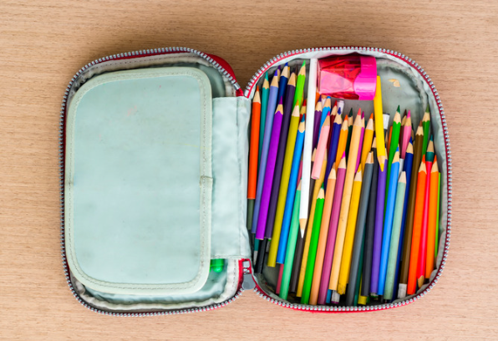
At a later stage, you can hand out cards featuring pictures or names of the objects for additional activities. Toward the end of the activity, ask the students to reflect on what named objects they carry in their own backpacks. Finally, engage them by asking which colors they know, encouraging them to share color names in different languages if they can.

Show the names of the colours. Find them in the brush stroke. Show the example. Ask to students: Are they all in the picture?
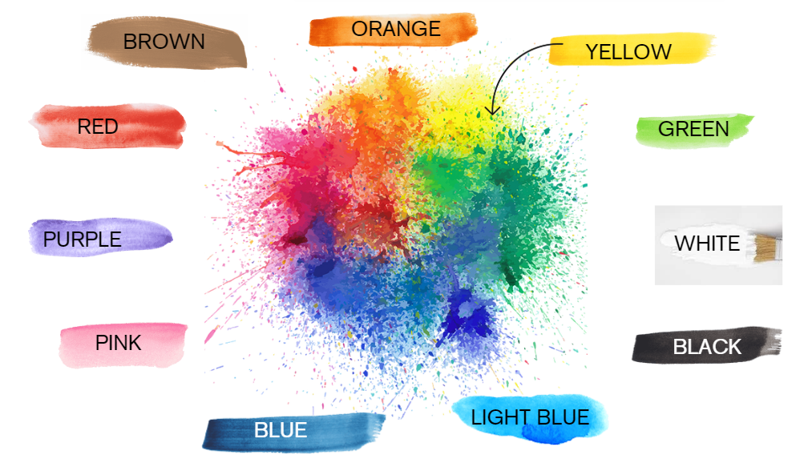

ACTIVITY 2 - Guess the correct objects
Read slowly the following sentences. Ask the students to look at the pictures and connect the objects in the correct cases.
“Abdullah has a green pencil case. In his pencil case there is glue, yellow scissors, an orange marker and a green marker, a pencil and two pens”.
“Tania has an orange pencil case. In her pencil case there are two erasers, a pen, a purple marker and a black marker, pink scissors”.
Which is Tania's case, and which is Abdullah's case? Connect the objects to the correct pencil cases. Write the name of the case and the quantity next to each item. For example:
Glue: 1 – Abdullah

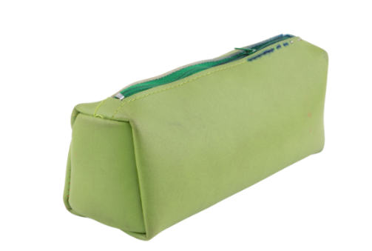

A2 students can read the sentences.

Use the following objects to complete the exercise 2.
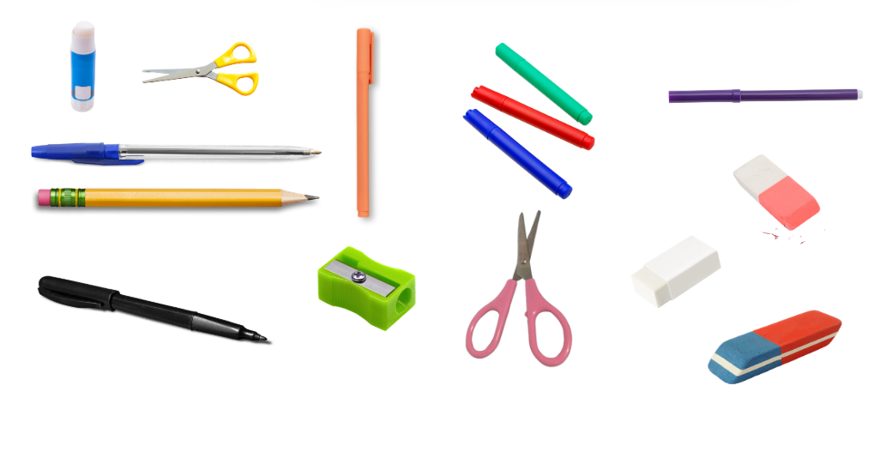

Alternatively, you can create posters in the classroom. The class can divide into small groups and each group can draw Tania's pencil case and Abdullah's pencil case.
Students can also draw the objects if they prefer.

Visual memory: what's missing?
The handkerchief game

ACTIVITY 3 - Search for objects
Split the students into groups. Each group has a list of objects that they must find around the school, either in their classroom or on tables where the materials had been previously prepared. The team that finds the materials first wins. Students can also work in pair. Each pair has the picture below, and the winner is whoever can find the materials from the list in the picture first. If you decide to use the picture, the materials that the students need to find are the following: eraser, scissors, orange marker, glue, pencil, yellow marker, exercise book.
A1 and A2 students can also write the names of the words.


ACTIVITY 4 -
Ask the students to observe the different school rooms in the pictures and answer to the following questions: Which school rooms do you know? Which ones are in your school? Which ones do you like and which ones do you dislike?
Gym
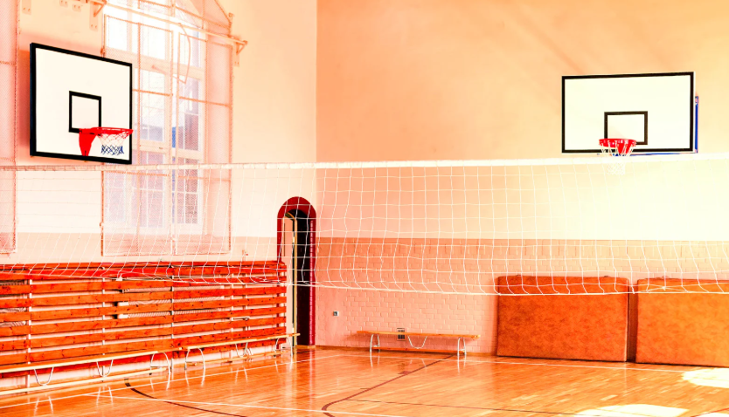
Library

Classroom
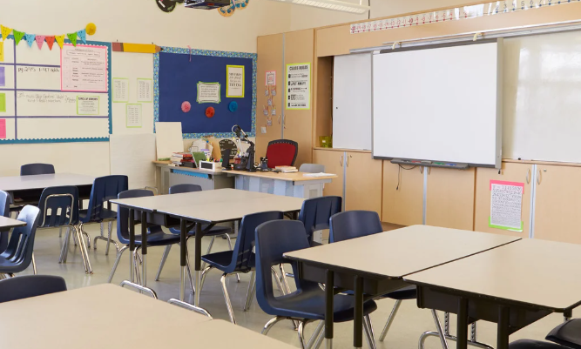
Canteen
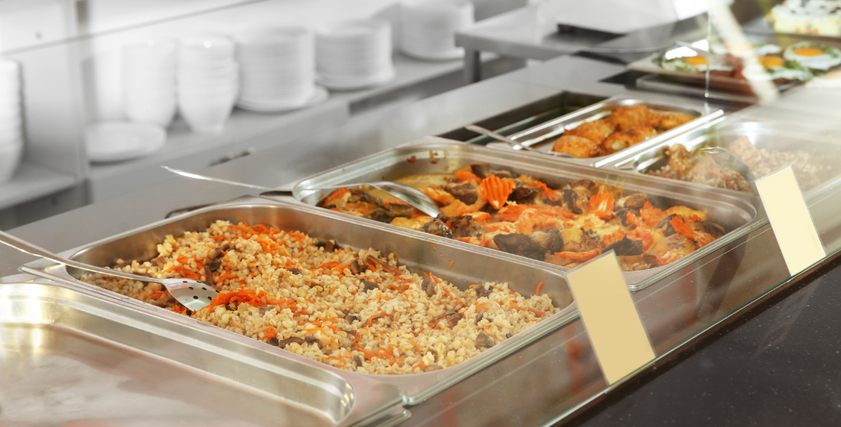

Entrance
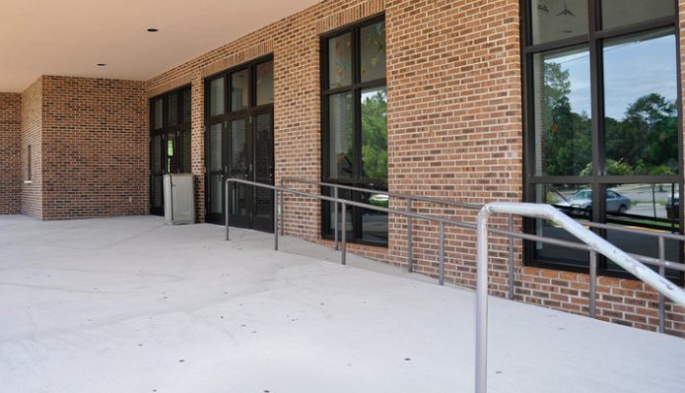
Bathrooms
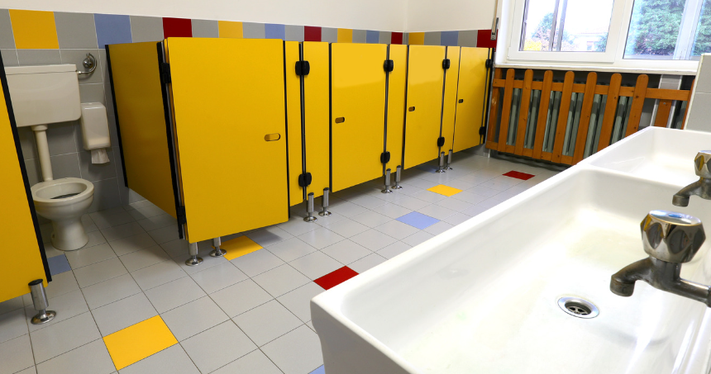
English classroom
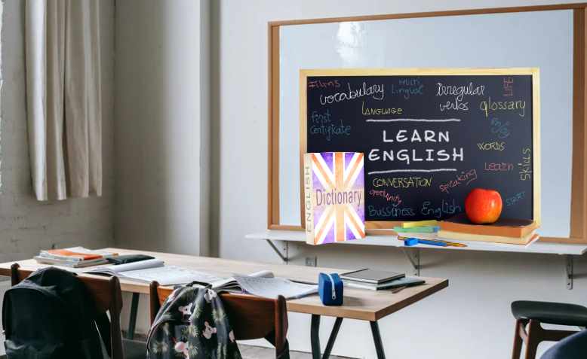
ACTIVITY 5 - Which subject do you like?
Guide the students to look at Tom’s timetable and ask students some questions. Read slowly the names of Tom’s subjects on different days of the week. Then, ask the students to compare Tom’s timetable to their timetable. For example, you can say: Tom does not go to school on Saturday, and he does not go to school on Sunday. Tom does not go to school in the afternoon either. Do you go to school at the weekend? And in the afternoon? Which subjects do you like?
Ask the A2 students to look at their week’s timetables and write down which subjects they like and do not like.
TOM’s timetable
Time | Monday | Tuesday | Wednesday | Thursday | Friday
8:30-9:30 | SPANISH | WRITING | PHYSICAL EDUCATION | MATHS | ENGLISH
9:30-10:30 | HISTORY | GEOGRAPHY | SPANISH | READING | HISTORY
10:30-10:45 | BREAK
10:45-11:45 | ART EDUCATION | ENGLISH | WRITING | MATHS | PHYSICAL EDUCATION
11:45-12:45 | READING | FRENCH | MATHS | HISTORY | FRENCH

Learning the days of the week and understanding the school timetable are fundamental for language development. It is equally important to explain how school functions in the host country. This includes understanding how many days of the week lessons are held and which day the school week begins, as this varies across the world. For instance, in some countries, Friday is a holiday instead of Sunday. Additionally, it is important to clarify how the school year is structured: when it begins, when it ends, and how holidays are distributed. In some countries, holidays occur during the summer months, from June to August, while in others, they are spread out over several weeks throughout the year. For example, a school year might start in January in some countries or in September in others.
Finally, explaining the seasons of the year is also crucial, as they differ around the world. While many countries experience four seasons, others, like Bangladesh, have six. This cultural and seasonal context is essential for students to better understand their new environment.

Let's play!

ACTIVITY 7 - Actions at school. Word-picture matching.
Ask the students to match pictures with the correct words.
1 |  | a | CUT
2 |  | b | DRAW
3 |  | c | RAISE HAND
4 |  | d | PAINT
5 | 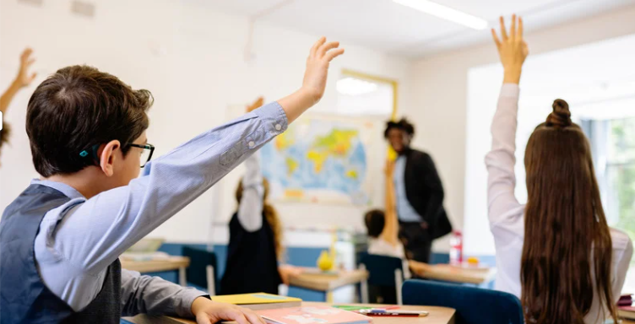 | e | WRITE
1.___ / 2. ___ / 3. ___ /4. ___ / 5. ___

Communicative reading
Find the intruder

During or at the end of Module 3, you can expand on:
- Verbs in the present or present continuous, if present and if used in different languages. In particular action verbs used in school such as, I am coloring or I am writing / I write, I colour.
- The expression what do you like? And the answer, I like ...
- Timetables.
- The expression what is missing? And its answer, for example an eraser is missing.
- Opinion verbs in the present tense such as I think, I believe, to complete sentences such as I think that an eraser is missing (for A2 students).
- Sentence structure with the main action such as in the canteen I eat, in the English classroom I study English (for A2 students).
- Some basic simple prepositions such as in.

Module 4 – Clothes and accessories

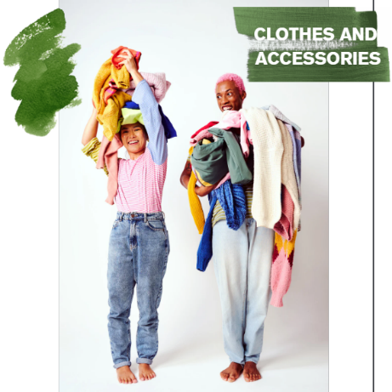

Activity index:
1. Do you know these words?
2. Guess who
3. Go shopping
4. How do I dress?
5. What's in the suitcase?
Content:
Main clothes
Main accessories
Clothes according to different weather
Dressing and undressing
Packing a suitcase

What do I need?
- Scissors.
- White sheets.
- Pencils.
- Pens.
- Blackboard.
- Pictures and photos as the ones used in the activities.
- Post-it.
- Real clothes and accessories.

ACTIVITY 1 - Do you know these words?
Guide the students in observing what Tom and Samia buy and then guide them in reading the words that appear below, next to the pictures. You can either use the clothes and the objects pictured below or find other clothes/accessories which are useful or necessary for the students in your context.
You could also bring a suitcase or a box with clothes or accessories inside. The use of authentic objects facilitates language comprehension because from an abstract language, students have an immediate and concrete reference, even to objects from their everyday lives.

TOM | SAMIA
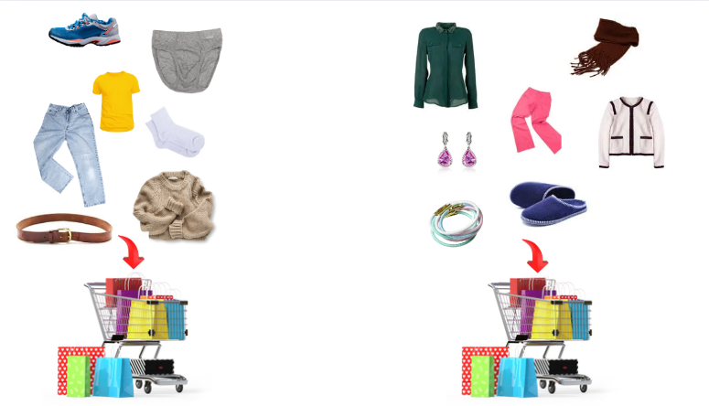

Now guide the students in reading the following words:
Trousers | Jeans | T-shirt
 |  | 
Pullover | Socks | Underwear
 |  | 
Shoes | Belt | Shirt
 |  | 
Jacket | Flip-flops | Hair band
 |  | 
Earrings | Scarf | Glasses
 |  | 

Now ask the students if they like shopping. Ask: Do you like shopping? What do you like to buy? Add other clothes and accessories that may be necessary for next exercises (like ‘hat’ or ‘bag’).
Dressing up for an event

ACTIVITY 2 – Guess who?
Show students the four pictures below and read slowly the following sentences. Students need to guess who the people are based on their description.
A. Jim is shorter than Marta. He has short hair, black trousers and a blue T-shirt.
B. Marta is tall, she has long hair, red trousers, a black jacket and red glasses.
C. Eleni is shorter than Jim. She has long hair. She has jeans and a handbag.
D. Adam has jeans, brown shoes, a black jacket and a hat.
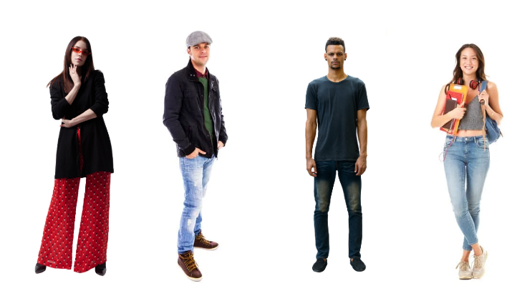

Guess the word.
Guess the object or the dress.
ACTIVITY 3 - Go Shopping
For Younger Students (ages 11-14):
  - Bring a variety of clothes, accessories, and items from home to use during the activity.
  - Divide the class into two main groups: buyers and shop owners. Divide the buyers into pairs. Assign each pair a budget of 100 euros for their purchases.
  - Divide the sellers into groups of three. Sellers decide on the type of shop they want (e.g., market, boutique, sports shop, accessory shop). Each seller’s group selects three items to sell and chooses a name for their shop, e.g., Friends’ Market.
  - Rearrange classroom tables to create individual “selling points” for each shop.
  - Each seller group sets the price for their items and assigns roles within their group: cashier, shop assistant, and possibly a fashion or product expert.
  - Provide both buyers and sellers with “language guide sheets” containing expressions to use in conversations.
  - Buyers move around the room, interacting with sellers to purchase items. Sellers actively market and negotiate sales.
  - After a set time (determined by you), switch roles: buyers become sellers and vice versa.
While the students interact with each other, keep track of items sold and their prices. Circulate throughout the room to provide linguistic support as needed, encouraging the use of the L2 (target language) while allowing other languages if helpful for sales and purchases.

For Older Students (ages 15-18):
  - Discuss with students whether they prefer a role play activity with freedom to design their scenarios or a more structured format.
  - Encourage creativity in the choice of items and the structure of the interaction.
Option A: Free-Style Role Play:
  - Divide the class into groups of three, with roles as cashier, shop assistant, and buyer.
  - Allow groups to determine the type of shop and build their dialogues independently.
  - Provide expression cards to guide their conversations.
Option B: Guided Role Play:
  - Assign specific buyer personas, e.g., a difficult customer or an agreeable one.
  - Groups design dialogues based on the personas and shop type.
While the students interact with each other facilitate group discussions, offer linguistic support, and monitor the role plays. Provide feedback to enhance language use and interaction skills.
Example of a card to facilitate communication:
Good morning, I would like a hat / ____________
How much does it cost?
It costs ... 20 euro
It's too expensive!
I really like it!
I don't like it!
Can I try it?
Can I try a bigger size?

A2 students can also give each other advice. For example, the person buying can say: I have to go to a birthday party. I would like a hat. What is the best hat for me, in your opinion? And the person selling can give advice, by saying: I think this is better for you, you have short hair, I think this hat is better for you.
ACTIVITY 4 - How do I dress?
Bring magazines to the students and ask them to describe verbally how different people are dressed. Make sure that the magazines are appropriate to your students’ age and cultural background.
Students can also decide to describe the teacher or their peers. Make sure that everyone is comfortable with being described and that descriptions are always respectful.
Students at A2 level may write the descriptions. Some students may also verbally suggest how and if they would change their clothing. For example: I think she looks better with a yellow scarf.

ACTIVITY 5 – What’s in the suitcase?
Show the video to your student and say or write on the blackboard: Valeria is very late. She has forgotten that she must leave. What does she put in her suitcase?
Show the video at least 3 times to PreA1 students and at least 2 times to A1/A2 students.
https://youtu.be/BJthaZJmsUY
Then ask the students to answer the questions. True or false?
Does Valeria pack the pink jumper? | T | F
Does Valeria pack the jeans? | T | F
Does Valeria pack green socks? | T | F
Does Valeria pack white socks? | T | F
Does Valeria pack a hat? | T | F
Does Valeria pack a belt? | T | F

For PreA1 students, you can provide images of clothes and accessories used in the video to answer True or False.
A2 students should also explain why the sentence is True or False.
You can also design the activity without using the video. In this case, bring a suitcase to school with real clothes and accessories. You can “pack together” with your students the suitcase.
Let's play with art!
Before or during Module 4, you can expand on:
- Parts of the body.
- Physical description of people (e.g.: tall/short; blond/dark)
- Explore sentence structures that allow for expressing personal opinions, such as I like it, I don’t like it because…, or I think this one is better than that one.
- Demonstrative adjectives and pronouns like this, that, these, and those, along with their respective functions in communication.
- Prices and costs and the expressions needed for shopping, for example: I like it, I don't like it, I would like it, I need it, I can try it

Module 5 – Health and emotions



c
Activity index:
1. How are these people feeling?
2. Specialist doctors
3. Illnesses and medicines
4. Emotions

Content:
Main illnesses and diseases
Main medicines and specialist doctors
Main emotions

What do I need?
- Scissors.
- White sheets.
- Pencils.
- Pens.
- Blackboard.
- Pictures and photos as the ones used in the activities.
- Real medicines packages.

ACTIVITY 1 - How are these people feeling?
Show the pictures and guide the students in observing them. Then say: How do you think they are feeling? What words do you know that could help describe it?
 | 
 | 
 | 

ACTIVITY 2 - Specialist doctors
2a. Ask the students if they know the names of doctors treating specific diseases or pains. For example If they do not see well, where can they go? To the gynaecologist? To the ophthalmologist or the dentist? Then ask the students to match the pain with the correct specialist doctor. Add as many pictures as specialist doctors as you want or need.
Ophthalmologist

Gynaecologist
Dentist

For PreA1 students, try different flashcards, pictures, newspaper cuttings or authentic flyers from health centres, hospitals or pharmacies. Ask them to identify people, and specialists and separate them from the medicines. The activity can also be carried out after exercise 3, and you can ask them to separate medicines from doctors.
If you are working with A2 level students, ask them to work in groups with a scenario. In the scenario, there is a person who is sick, and they have to write down which doctor they should go to and what medicine they should take. You can also give them a pre-filled form they have to complete with missing information (e.g.: name of the patient, pain or illness, type of doctor to go to).
You can also ask A2 level to explain verbally what a dentist, ophthalmologist or general practitioner do.

2b. Read the following text and ask the students to complete the table below:
Dr Khan, dentist. Patients' visiting hours are:
Monday to Friday from 08:30 am to 1.30 pm and from 3.30 pm to 7.30 pm.
For emergencies on Saturdays and Sundays call the number of the general practitioners in the hospital always available: +44 5454732342
Dr Khan's centre is located at boulevard 23, floor 4, interior 1.
What is the name of the doctor?

What does he do?
Does the doctor visit every day?

What is the general number in case of need?
You can ask PreA1 students to choose the right option from the following table.

Doctor's speciality: | - Gynaecologist  - Dentist  - Ophthalmologist
Visiting days: | - Mondays and Saturdays  - Saturday and Sundays  - From Mondays to Fridays
Emergency number? | ……………………………………………….
Students at A2 level can fill in the following table (true, false or not given). Provide examples first and explain what not given means:
 | Dr Khan is a medical specialist | T | F | Not given
 | Dr Khan is not a general practitioner | T | F | Not given
 | There is an emergency medical service on weekends. | T | F | Not given
 | The dentist does not take a lunch break. | T | F | Not given
 | Dentist visits are free of charge | T | F | Not given
Bring real materials like leaflets from doctors or specialists and medicine packages (e.g., sprays, tablets) to class. Include emergency numbers and basic information about the local, public, and private healthcare systems, as well as private insurance options if relevant. Real objects help make language easier to understand. Ask Pre-A1 and A1 students to find words from Linguistic Domain 5 in the materials you bring. For example:
- In a flyer about allergies, they can find words like "spray" or "allergy."
- On a cough syrup package, they might find "syrup" or "cough."
This makes abstract concepts more concrete and engaging.

To get students to play with languages, you can ask them to use Google Lens or other translators and translate the texts on medicine packages or leaflets in the languages they want. Ask the students if they recognise the languages of the translator, if they recognise the sound of the words, if they are similar or very different from the language they are studying.
ACTIVITY 3 - Illnesses and medicines
Ask the students to read the names of some basic medicines. As in the previous exercise, it is advisable to bring to class authentic medicine packages used in the country in which you are teaching. Students try to match the medicine to pictures of people who looks unwell. For example: Nose spray matches to the person who has a cold.
  1. | a. Nose spray
  2. | b. Tablets
  3. | c. Syrup
  4. | d. Eye drops
Tips for a friend

ACTIVITY 4 - Emotions
4a. Ask students to work with emoticons from WhatsApp or other social media to explain some basic emotions. Ask them to match the emotions with real pictures.
 | 
 | 
 | 
 | 

Ask students how they say the following emotions in other languages. Help them to define how to say them in the second language that you are teaching.
4b. Organize students into groups and ask them to respond to a WhatsApp message from a friend using only emoticons. They can share their responses in the class WhatsApp group (if one exists) or upload them to a file in a shared drive set up by the teacher. Afterward, each group:
- Sends a voice message or explains verbally what their emoticon response means.
- Discusses whether it’s possible to interpret the message differently.
- Writes alternative interpretations of the message in the chat or on the shared file.
Here’s an example to illustrate the activity:
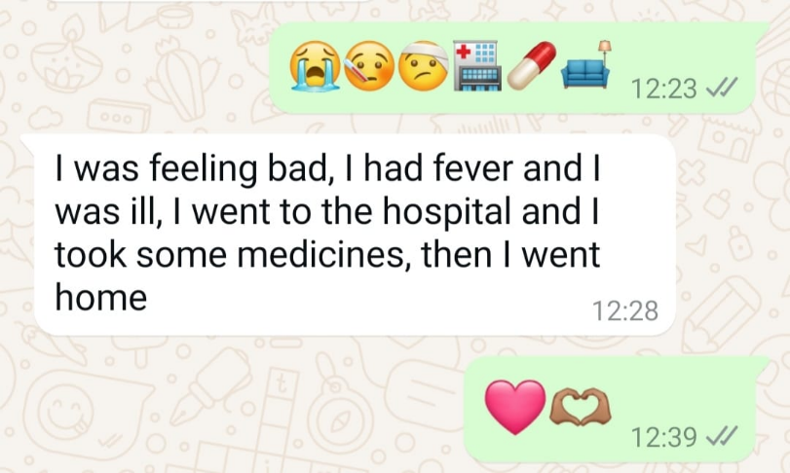

4c. Bring a jar in the classroom and ask the students to fill it with a word (in any language), a picture, a song or a sentence which represent happiness for them. You can ask the students to bring a different item at each language session or class. Together, decide when you will open it the jar and observe what they put in the jar (for example, during the last class together or at the beginning of summer holidays).

Before or during Module 5, you can expand on:
- Parts of the body.
- Specific formulas such as I am well, I am ill, I feel..., I have pain.
- Difference between pain, illness, and disorder.
- Modal verbs.
- Telephone numbers and times.

Module 6 – City, neighbourhood and leisure time



Activity index:
House or home?
Your favourite house
Going out
City and directions
Leisure time

Content:
Parts of the house
Types of houses
Cities and neighbourhood
Main words related with cities
Leisure time
Directions

What do I need?
- Scissors.
- White sheets.
- Pencils.
- Pens.
- Blackboard.
- Pictures and photos as the ones used in the activities.
- Tape.
- Glue.

ACTIVITY 1 – House or home?
Ask students if they know how to say "home" in the second language you are teaching.
Explain that in some languages ​​there is a difference between a physical place and a family, the environment in which a person can grow up. In English, for example, you can say "house" but also "home." Ask them if they know which word in English refers to a physical place.
Ask students if they know of other languages ​​in which the word house can be said in different ways and what they mean.
For example, in Bangla language there are two different ways, one is বাসা (Bāsā) and the other is বাড়ি (Bāṛi). The first one refers to the physical place, the second one to the family that grows with you, to the neighbourhood where you grow up and has an emotional and affective bond. Invite students to also use online translators and to explore the two terms in different languages. This activity can be done at school but can be expanded as a homework.
For many students, speaking about their house or their family could be a sensitive topic. If you feel it could be a trigger for one or more students, skip the first part of this Module and work on topics related to city and the neighbourhood.

ACTIVITY 2 – Your favourite house
2a. Ask students the following questions:
Look at these pictures. Which is your favourite house? Why?
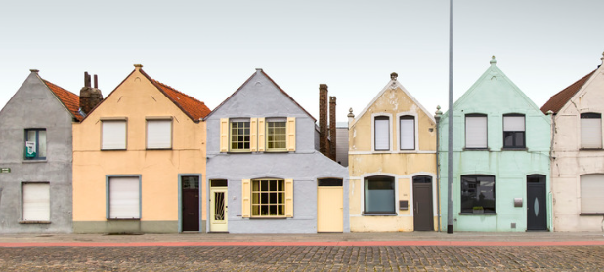



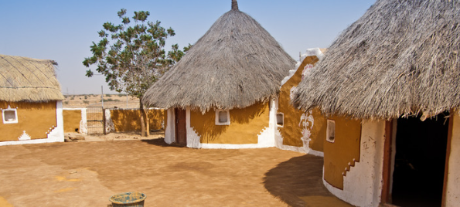
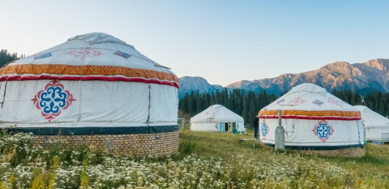

A2 students can describe the houses they choose while students from other levels can say the words they know.
To play the games in the Game Bank and explore the house theme, students need to learn about interiors, room names, building floors, and the objects and furniture in each room. Additionally, explain how housing structures differ across countries where L2 is taught. For instance, in Spain, doorbells typically show the floor and door number (e.g., "floor 4, door 2") instead of residents' names. In Italy, however, doorbells must include the residents' full names. Adapt the activity to fit the specific cultural context of each country.

2b. Ask students to work in pair and paint, build or draw the house they would like to live in. To draw or build their dream house bring in the class recycled material, coloured paper, magazines, etc. Then each group presents their house to the class. Ask what they would like inside their house, for example a large bed, a small television, two bathrooms, etc.
Guess the contents of the box
ACTIVITY 3 - Going out
In this activity, guide students in discovering the names of different places they can find in a city, in a park, in a village or at the seaside. The images below are just examples, use relevant images for the participants based on your context. Ask students which places they know, and which places they like. Prepare flashcards with the names of different places, and guide students in matching place names with pictures.
You can also ask students to circle the places they know in the pictures and write the words they can fill in.
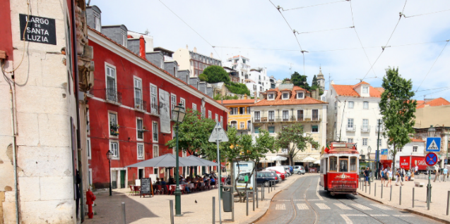

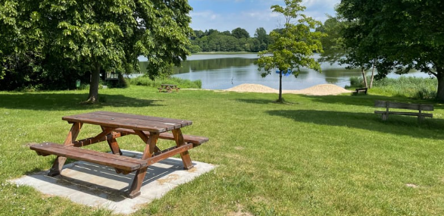

ACTIVITY 4 - Cities and directions
4a. This activity focuses on giving and understanding directions, such as "go straight, turn right, after the park, keep going straight," and so on. Start by teaching different directions in class and providing city maps as examples. Students can choose specific places and create routes by describing them aloud, or follow a pre-set route (e.g., from home to the supermarket) while explaining the steps.
You can also ask students to play in pairs. Student A has a city map and selects places and a route (e.g., from home to the supermarket and then to the cinema). Student B, with the same map, listens as Student A gives directions and traces the route. The marked route should match the one Student A described.
4b. Ask students: What do the traffic lights look like in the city where you live now? Are they similar or different from the ones you, see? Can you guess what these drawings on the traffic lights mean?
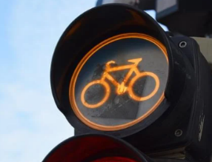
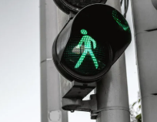
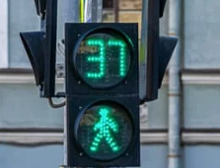

If appropriate, you can also do this activity outside, walking around the school and in the neighbourhood of the school or educational centre. While walking, you can show major road signs such as stop signs and the colours of the semaphore.

Matching words and images in the city
Plurilingual landscape
ACTIVITY 5 - Leisure time
5a. Show images of actions that teenagers and youth can do in their free time – such as partying, playing a sport, listening to music, talking to friends, going to the library and reading. Divide students into groups and ask them to interview each about what they like to do in their free time. Then, provide a map of the city where they live ask them to map their favourite places and specify why they like them and why not.
5b. Read the following text. Read it at least three times for PreA1 level students and two times for A1 and A2 level students:
Anita wakes up early in the morning. Then she goes to work. She works from 9 to 16. In the afternoon, in her free time, she likes to grow plants in a garden.
PreA1 students listen and rearrange the images of the story.
A1 students connect images of the story and short sentences or words if they cannot read sentences yet.
A2 students can write the words they hear or entire sentences under the story.

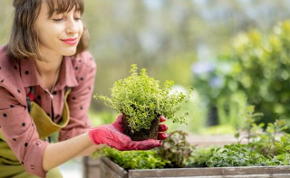 |  | 
A plurilingual Podcast

Before or during Module 6, you can expand on:
- Verbs for giving directions.
- Prepositions of place (under, beside).
- Prepositions of time (in, on, at).
- Places.
- Interrogative, affirmative and negative sentence structure.
- Expanding there is / there are.
- Verbs indicating action such as I go to, I turn right.
- Expressions such as my favourite is, I like it, I prefer.

References

Michel Candelier, M., Camilleri-Grima, A., Castellotti, V., De Pietro J., F., Lőrincz, I., Meißner, F., J., Noguerol, A., Schröder-Sura, A. (2012). FREPA A Framework of Reference for Pluralistic Approaches to Languages and Cultures Competences and resources. Graz, European Centre for Modern Languages / Council of Europe. https://www.ecml.at/portals/1/documents/ecml-resources/carap-en.pdf

Council of Europe. (2020). COMMON EUROPEAN FRAMEWORK OF REFERENCE FOR LANGUAGES: LEARNING, TEACHING, ASSESSMENT. Companion volume.
https://rm.coe.int/common-european-framework-of-reference-for-languages-learning-teaching/16809ea0d4

Cummins, J. (1980). Psychological assessment of immigrant children: Logic or intuition? Journal of Multilingual and Multicultural Development, 1, pp. 97-lll.

Cummins, J. (2008). BICS and CALP: Empirical and Theoretical Status of the Distinction. In: Hornberger, N.H. (eds) Encyclopaedia of Language and Education. Springer, Boston, MA. https://doi.org/10.1007/978-0-387-30424-3_36

Baker, C. (1996). Foundations of Bilingual Education and Bilingualism. 2nd ed. Clevedon, Multilingual Matters.

Bligh, A. C. (2014). The silent experiences of young bilingual learners: A sociocultural study into the silent period. Sense Publishers.

Brinkmann, L. M., Duarte, J., & Melo-Pfeifer, S. (2022). Promoting Plurilingualism Through Linguistic Landscapes: A Multi-Method and Multisite Study in Germany and the Netherlands. TESL Canada Journal, 38(2), 88–112.
https://doi.org/10.18806/tesl.v38i2.1358

Dörnyei, Z. (2001). Motivational Strategies in the Language Classroom. Cambridge, Cambridge University Press.

European Commission, Directorate-General for Education, Youth, Sport and Culture. (2016-2017). Rethinking language education and linguistic diversity in schools. Rethinking language education and linguistic diversity in schools - Publications Office of the EU

European Commission, Directorate-General for Education, Youth, Sport and Culture. (2019-2020). Education begins with language. Education begins with language - Publications Office of the EU

García, O., Wei, L. (2014). Translanguaging: Language, Bilingualism and Education. Palgrave Macmillan, Basingstoke, U.K.

Harmer, J. (2015). The practice of English Language Teaching- 1st edition. Pearson.

Krashen, S. (1981). Second language acquisition and second language learning. Toronto, Pergamon Press.

Vallejo, Rubinstein, C.; Tonioli, V. (2023). Exploring the Linguistic and Cultural Identities of Transnational Background Children in Catalonia, Spain. SOCIETIES, vol. 13 (ISSN 2075-4698), https://doi.org/10.3390/soc13100221

Webography

The New ABC project. Available at: https://newabc.eu/

The UNESCO website on mother tongue and plurilingual pedagogies is available at:
https://www.unesco.org/en/articles/why-mother-language-based-education-essential

The European Commission guidelines on Key Competences for Lifelong Learning are available at:
https://education.ec.europa.eu/focus-topics/improving-quality/key-competences

The European Commission guidelines on Literacy and Second Language Learning for the Linguistic Integration of Adult Migrants (LASLLIAM) are available at: Launch conference of the new reference guide LASLIAM - Linguistic Integration of Adult Migrants (LIAM)

The European Commission Bank of supplementary descriptors of the CEFR for Young Learners are available at: Bank of supplementary descriptors - Common European Framework of Reference for Languages (CEFR)

If it is necessary to teach a second language to illiterate or low-literate students, it is necessary to use another methodology and refer to the new reference guide on Literacy and Second Language Learning, LASLLIAM. The guide was designed for illiterate or low-literate adults and not for young learners, but it is the only European document currently available for that specific target group of learners.
Some of the guidelines have been readapted from New ABC project, Horizon 2020 (https://newabc.eu/)
To know more on HC you can open the following link: https://www.rescue.org/uk/irc-uks-healing-classrooms and this one on the evidence linked to HC: https://airbel.rescue.org/projects/the-impact-of-ircs-healing-classrooms-tutoring-and-targeted-socio-emotional-learning-activities-on-childrens-learning-and-social-emotional-outcomes-in-conflict-and-crisis-settings-3ea/
See Bligh (2014) for further discussion.
See Cummins (2008) for more on these issues.

