Table of Contents
Introduction to the Game Bank 3
Who is this Game Bank for? 3
How to use the Game Bank 3
Sensitivity guidance 3
Socialization games and icebreakers 5

DISCLAIMER:
Co-funded by the European Union. Views and opinions expressed are however those of the author(s) only and do not necessarily reflect those of the European Union or the Asylum, Migration and Integration Fund (AMIF). Neither the European Union nor the granting authority can be held responsible for them.

Introduction to the Game Bank
Welcome to the Theory of Change – XX Game Bank for language learning! The Game Bank is produced by the International Rescue Committee (IRC) in the framework of the "Theory of Change: the use of the art of Rhetoric Speech as an innovative tool" (ToC) project. ToC It is co-funded by the Asylum, Migration and Integration Fund (AMIF) of the European Commission (101141204). The project is intended to address the challenges faced by migrant children in integrating into host societies, particularly focusing on education and language learning. It aligns with European Commission initiatives and the EU Strategy on the Rights of the Child, emphasizing the rights of all children, regardless of their background.

Who is this Game Bank for?
The Game Bank contains a set of activities and games designed for L2 teachers, educators and social workers who are involved in facilitating the education and social and linguistic inclusion of children and adolescents with a migration background. The activities are designed for children between the ages of 11 and 13 and adolescents between the ages of 14 and 18, with a focus on those who have recently arrived in the new host country and with a language level from CEFR level PREA1 and CEFR level A2. They specifically target students who are literate in their home languages, which means that the students who will use them can read and write in one or more mother tongues. If it is necessary to teach a second language to illiterate or low-literate students, it is necessary to use another methodology and refer to the new reference guide on Literacy and Second Language Learning, LASLLIAM. The guide was designed for illiterate or low-literate adults and not for young learners, but it is the only European document currently available for that specific target group of learners.

How to use the Game Bank

The Game Bank is linked to the Theory of Change Toolkit, which provides a theoretical framework for promoting second language acquisition in plurilingual and intercultural contexts. The Toolkit also contains linguistic domains (e.g. introducing oneself, buying food, walking around town) with activities based on CEFR level A1. For some activities, there are suggestions for adapting them to other levels, for example, to a lower level, PreA1, or to a higher level, such as A2. The language activities in the toolkit also vary according to age: some are recommended for students aged 11-13, others for students aged 14-18. Within each linguistic domain, the titles of the supplementary games are included in this Game Bank.

What kind of games are included in the Game Bank?

The Game Bank is divided into three sections. First, there are the socialisation games, icebreakers, then intercultural games and finally the language games linked to the different linguistic domains of the toolkit.

What is the function of the games in the game bank?

Some games are useful for socialising, introducing and getting to know each other between teachers/educators and students. Other games, which are more intercultural, serve to enhance all the different linguistic and cultural repertoire present in the class or group of pupils, without ever forcing the use of the mother tongue, but encouraging the use of different languages other than the second language, to promote learning in a multilingual context that respects and welcomes diversity.

Language games, on the other hand, are extensions of the activities in the toolkit.
They are indicated in the Toolkit by this symbol:
For example, if the Toolkit contains exercises using the vocabulary of greetings, the Game Bank contains games to use the linguistic formulas of greetings. That enables students to reuse them in different contexts in a playful way and to vary the learning techniques, it is also designed with an intercultural focus. In addition, language games often offer dynamic alternatives to more traditional activities. Outdoor activities, digital, artistic and multimodal activities, such as creating an intercultural and linguistic podcast, play-based activities and cooperative learning activities are presented.
Can I adapt the games to the needs of my learners and the context?
All the games in the Game Bank can be adapted according to the context, the needs and wishes of the pupils and what they want to do most. The duration is variable and can also be adapted to different needs. As in the Toolkit, some games in the Game Bank are suitable for pupils aged 11–13-year-olds and others for students aged 14–18-year-olds.

Sensitivity guidance

Before engaging in activities from the Game Bank, it is crucial to consider practices that respect the diverse sensitivities of participants. The following guidelines can help establish a classroom environment that acknowledges and values the identities, abilities, and experiences of children, fostering inclusivity and mutual respect. Incorporating a psychosocial approach in language education not only supports students in managing stress and trauma but also enhances their overall well-being. This foundation enables better focus, improved information retention, and a more effective learning experience.
By following these simple recommendations, facilitators can create a nurturing and healing classroom atmosphere that promotes both emotional and academic growth. Below are specific practices to guide facilitators in addressing core aspects:
1. Identity
- Recognize and address the marginalization of children from certain backgrounds, ensuring an equal and inclusive environment for all.
- Maintain a zero-tolerance approach to teasing or bullying based on differences.
- Avoid showing favoritism toward any group.
- Use discretion when pairing children from different groups early in the intervention. As they become more familiar with one another, integration will feel more natural.
- Adapt activities to account for gender dynamics, such as avoiding physical contact, dividing the class by gender when appropriate, or modifying discussions that involve sensitive topics.
2. Abilities
- Foster a safe and welcoming atmosphere where all children feel accepted and valued.
- Intervene immediately to stop any form of discrimination.
- Modify activities to ensure participation is accessible to all children, regardless of their abilities.
- Prioritize inclusivity, recognizing the unique strengths and contributions of each child.

3. Experiences
- Take time to learn about the children’s backgrounds and any significant life events they may have experienced.
- Avoid placing undue pressure on children to answer questions or participate beyond their comfort level.
- Provide individual support if a child becomes upset, attending to them privately and offering reassurance.
- Be mindful of how other children react to a peer’s distress, and prevent judgment or stigmatization. Encourage empathy and understanding instead.

Socialization games and icebreakers

Why socialisation games at the beginning of a language course?
Socialization games are necessary to create a relaxed and welcoming learning environment for all students, teachers and educators. At the beginning of a course or an activity the creation of a positive environment is crucial. The games below are useful for students to introduce themselves, fostering teamwork, expressing their preferences and needs. Those games are also important for teachers and educators at the beginning to better know students, to evaluate their communication and linguistic skills and to learn about their prior linguistic knowledge.

GAME 1 - My passport
- Provide each student with a blank "passport" template, including sections for personal details such as Name and age, Hobbies, Favorite animals, games, and foods, Countries they dream of visiting. To support understanding, provide visual aids (e.g., icons or images) next to prompts like “Favorite Game” or “Favorite Animal.”
- Encourage students to fill out their passports using drawings, pasted pictures, or written words, depending on their abilities and preferences.
- To support understanding, provide visual aids (e.g., icons or images) next to prompts like “Favorite Game” or “Favorite Animal.”
- Once completed, gather all the passports.
- Create a mural or display featuring all students’ passports to celebrate the diversity and creativity of the group.


If children are not ready or comfortable introducing themselves verbally, do not insist. Allow them to participate at their own pace and comfort level.

GAME 2 – Presentation with pictures
- Ask students to sit on a circle.
- Provide them with a deck of cards – it could be any deck of cards: pictures you select from the Web, board game cards, drawings etc.
- Ask all students to choose an image they like and glue it on a coloured sheet writing their name on it.
- If they have the linguistic competencies, students can also introduce themselves and explain why they chose the picture.

GAME 3 – Presentation with movements
- Ask students to stand in a circle.
- Say your name combined with a specific movement. For example, if your name is Mark, say ‘Mark’ and make a jump. Ask all students to do the same with their names and the movements they prefer.
- In turn, everyone should try to call other classmates by remembering their name and the matching movement.

GAME 4 – 1, 2, 3 STAR!
- Arrange students along a wall in a row and explain that their goal is to reach the wall according to instructions and to stay still when you will say “STAR”.
- Turn against the opposite wall and shout “1, 2, 3 STAR!” and turn around.
- Students who are able to stand still can continue to play.
- In the next rounds, students try to reach the wall according to instructions. For example, before counting you can say “ELEPHANTS… 1,2,3 STAR!” or “FROGS… 1,2,3 STAR!” or “JUMPING… 1,2,3 STAR!”. You can invent as many new ways as you wish.
- Continue until one of the students reach the wall.


Remember to:
- Make sure that everyone can run, walk or jump without any problems.
- Make sure that everyone knows the movements, actions or animals you want them to follow.
- To facilitate understanding, you can show the pictures of the animals or the movements before the beginning of the game.

GAME 5 – Travelling suitcases
- Give to each student a picture of a suitcase and ask them to decorate it, paint it or modify it to represent their own suitcase.
- Ask students to think and write in the suitcase words which are important to them, and they always want to carry with them on every trip (e.g. from home to school, or from reception centre to the education centre). They can also use their mother tongue or any other language they know. In addition to words, they can also glue images they like or that represent them, labels of foods or products that they love, brands that they like, etc. They can also bring objects to place near their “suitcase” – for example, they may want to always carry a book, a perfume or a bracelet.
- To conclude, students can explain the content of their suitcase to the class, explaining their choices or show what they have included.

This is an activity conducted in Barcelona during the New ABC project. At the following link you can find further instructions on how to prepare the activity and see how the final products can look like.
https://www.mdpi.com/2075-4698/13/10/221

Intercultural games

Why intercultural games in the Game Bank?
The purpose of these activities is to highlight the students' entire linguistic repertoire, giving them visibility and value within the classroom. This approach helps students appreciate the ‘language capital’ they possess, fostering a sense of pride and strengthening their self-esteem. These activities create a positive and empowering perspective on their language and intercultural communication skills by focusing on what they know rather than what they do not know. Such games foster mutual knowledge but also the appreciation of cultural diversity that leads to cultural awareness, encourages active listening between students, empathy, dialogue and mutual respect.
As stated in the Toolkit, the importance of valuing all different languages and cultures at school and considering the plurilingual speaker as an asset is also an indication of the European Commission's aim to reduce early school leaving and to provide all students with the same opportunities. The empowerment of all the stakeholders by the use of different linguistic and cultural repertoires is recommended in the educational and language acquisition process. Such a choice also brings the students' families closer, feeling more welcomed and involved in their children's education and may also foster more meaningful links between schools or education centres and families or, more generally, between the whole educational community involved.
Finally, the use of different linguistic and cultural repertoires favours the acquisition of second or other languages.
These activities can also be used as icebreakers to introduce students to each other.

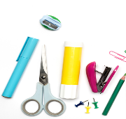
GAME 1 - The language flower
What do I need?
- Scissors.
- White sheets.
- Coloured cards.
- Blank flower shapes.
- Glue.
- Scissors.
- Pencils.
- Ask students to draw themselves or write their name in the centre of the flower shape.
- Ask them to reflect on the different languages they speak, understand or know and to write the names of the languages in the different petals, following these instructions:

    - The languages I speak: red
    - The languages I do not speak but understand: blue
    - The languages I can read and understand: green
    - The languages I do not speak but have heard: white
    - The languages I don't speak but I can see written: yellow
    - The languages I would like to learn: orange
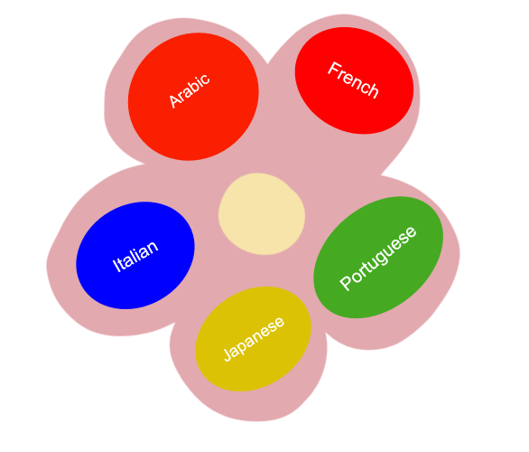
- Everyone can then explain their own flower
- Build a poster or a mural with all the different flowers, creating ‘paper flower garden’.
- If it is possible, reflect together on the different existing languages, on the languages that students would like to learn and on the skills that they have in other languages (for example, they might be able to understand three languages, but speak just two). You can also reflect on the languages used in your context (e.g. in the school, the neighbourhood, the city)
You can find many versions of this activity online. We offer the original present version of CARAP/FREPA: A framework of reference for pluralistic approaches and proposed by Masat D. and Moore E. of the GREIP group (UAB University of Barcelona) and repiloted during the New ABC project in Spain and Italy.

GAME 1 - The linguistic biography or plurilingual portrait.
Language biography is an alternative to the language flower (GAME 1) and is particularly suitable for students aged 14-18,
- Provide each student with an outline of a person.
- Everyone must write down the languages they speak, know and can write within the shape of the person, including dialects and language varieties. Students can use their mother tongue or any other language they know.
- The placement of the language within the body is decided by the students, for example, one student may write their mother language in the legs and the language they are acquiring in the hand, another may choose to write his mother tongue in the heart area and the language being studied in the head.
- The teacher can guide the students on the body parts and ask them to give value to different areas such as the heart. By assigning importance to parts of the body they can then infer the importance of each language to them.
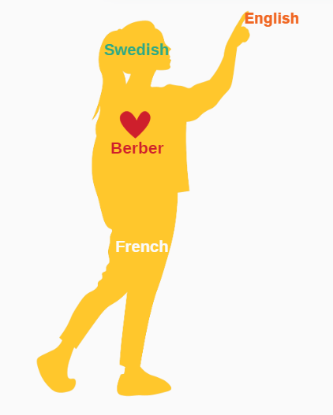
The activity allows teachers and participants to enhance all language repertoires in the classroom but also to understand which languages the children know, would like to use in the classroom or not. An example of the linguistic portrait is the following:
The young girl has written the name of her mother tongue in her heart, Berber. In her legs, she has inserted the French language because it is a language that has supported and helped her in her studies and travels. In her hands we see the English language because she now uses it as a vehicle and communication language. Finally, in the head we find the Swedish language because it is the second language she is learning, and it is very tiring for her and causes her some headaches.
The image is created for the purpose of explaining the activity.
You can find more details and further instructions here: European Toolkit for Language Teaching to Refugees.

Linguistic domain 1 – Personal Presentation

In this module, you will find games and exercises related to the first linguistic domain of the XX Toolkit.

GAME 1 - World map
- Show the students a world map and ask if they know the names of other countries around the world.
- For each country they choose ask if they know what language is spoken in the country and if they can write a word or a greeting in that language. For example, if they know the Spain, they can write 'hola'.
Hola



Expand the activity by using the free Padlet app to create an interactive world map showcasing the languages students know. Start by setting up a map on Padlet (free accounts allow up to three projects). Students can use mobile devices to add a word or phrase in a language they know, pinning it to the region where the language is spoken.
For example, they might add “Good morning” in both Spanish and Catalan for Barcelona, along with an audio clip or written text. They can explore greetings in other places, like adding “Buongiorno” for Rome or notes on communication styles in New York City.
Students can also engage by liking or commenting on each other’s posts with text, audio, or video. At home, they can research more languages and cultural details to expand the map.
Check out this example of a greetings map: Greetings in Many Languages.
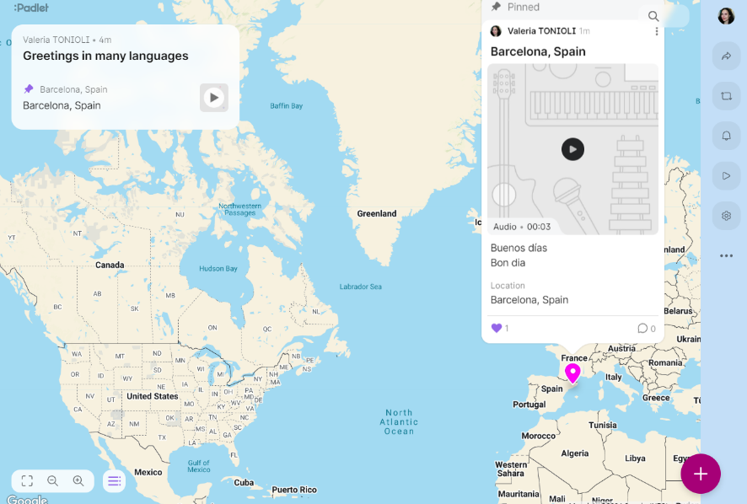
This simple activity encourages language sharing, cultural exploration, and creative expression, even for beginners.

GAME 2 – Greeting gestures
- Ask students how people greet each other in the countries they know – including their country of origin if appropriate. Ask them if it is appropriate to greet by shaking hands or kissing.
- Ask them to explain how they introduce themselves in different countries, (for example one student could explain that in Italy one usually shakes hands while in Spain it is commonly accepted to give two kisses on the cheek, starting with the right cheek even when meeting someone for the first time).
- To support discussion, use the pictures below to discuss different ways that people greet each other in the world.
 | 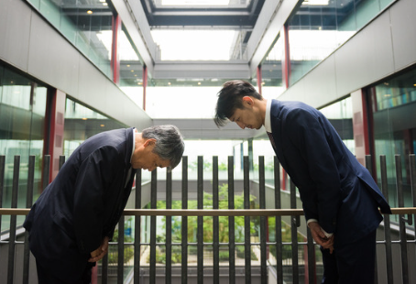
 | 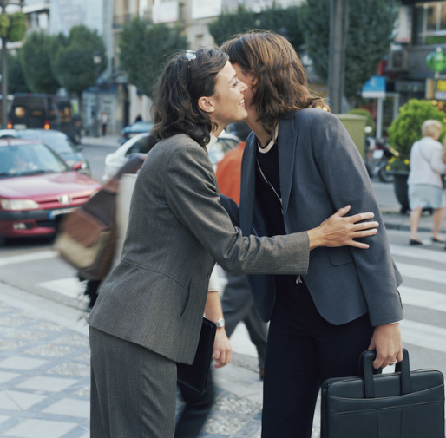

GAME 3 – Visual memory
- Show the two pictures below to the students for 30 seconds. Ask them to remember as many details of the pictures they can.
- Prepare a set of questions that they need to answer without looking at the pictures. The one who remembers the most information wins.
For example you can ask: How many boys are there? How many girls? Is it day or night?
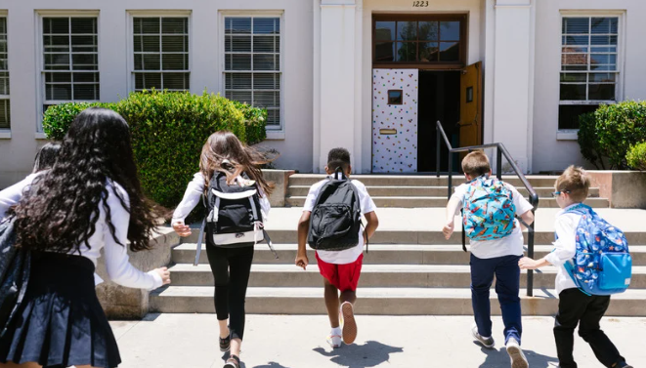


GAME 4 – Find the words
- Prepare a puzzle as in the example below and print as many crosswords as students in your class.
- Ask the students to find the words both horizontally and vertically
In this example, they must find the following words: NAME – NATIONALITY – COUNTRY – AGE – GOODMORNING – HELLO – NIGHT – GIRLS – BOY
(In yellow you will find the example and in bold the solutions).
X | X | R | N | A | M | E | X | X | F | R | X | A | X | X
E | R | T | A | T | T | T | U | I | U | U | U | U | U | U
X | C | V | T | V | X | X | X | X | G | I | R | L | S | Z
Z | Z | W | I | Q | Q | Q | R | T | Y | Y | I | O | P | G
X | X | C | O | U | N | T | R | Y | U | U | U | U | U | U
C | C | C | N | Q | W | R | T | T | T | U | H | I | I | O
C | C | B | A | G | E | V | B | E | R | T | E | T | T | P
X | X | X | L | Y | Y | Y | U | T | T | T | L | T | T | B
X | R | N | I | G | H | T | C | C | C | A | L | E | G | U
W | R | A | T | A | V | B | T | G | H | B | O | Y | H | J
J | J | K | Y | L | O | P | E | R | W | A | D | R | G | H
G | O | O | D | M | O | R | N | I | N | G | X | X | W | W

- Then prepare a crossword as in the example below and print as many crosswords as students in your class.
- Ask the students to solve the clues to complete the crossword.
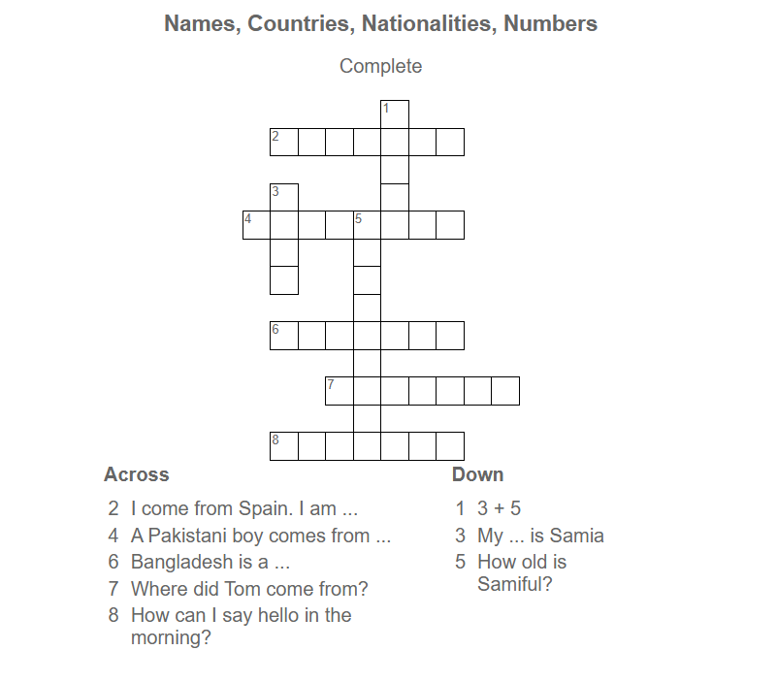

To create free crossword puzzle activities, you can do it by hand on a board or employ free apps found online such as LearningApps.org, Puzzle-marker, Wordwall, as well as many others.

Linguistic domain 2 – Food and drinks

GAME 1 - Cook and take a picture
1a.
- Ask the students to prepare a dish or a drink they like such as a smoothie and to take a photo of it and post it on social media or share it with the rest of the class. If students do not want or cannot cook, they can also share a dish prepared by other people.
- Ask other classmates to guess the ingredients used in the recipe. Suggest to use the food and drinks they learnt from Activity 1 of the Toolkit.
- Check together whether the ingredients have been guessed.
- Count and indicate how many students like or dislike the shared dishes.
1b.
- If possible, organize for the class to go to the market together.
- Ask students to prepare a shopping list with things they would need to prepare their dish.
- Once at the market, split students into teams and ask them to take picture of all the needed ingredients in the shorter amount of time and upload them in the class WhatsApp chat or Drive folder.
- Ask students to combine all the pictures they took with the emoticons usually available online, as in the following example.

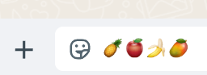

If students are too young or do not have access to social media, each group should be accompanied by a facilitator or a teacher who will take pictures for them without uploading them to social or WhatsApp groups.

GAME 2 - Let's play!
- Split the students in two teams and make them stand in a column.
- Each team has pictures of food and drinks on coloured cards. For example, Team 1 has 10 items of food and drinks on a yellow card, Team 2 has 10 items of food and drinks on a red card.
- Set up two containers, one for food and one for drink.
- In turn give the OK for each student to run and place a card in the right box.
- The team that has correctly placed the food and drinks in the right box wins.
You can also modify the activity as follow:
- You can do the activity either in the classroom or outdoor.
- You can also decide to separate fruit from vegetables, or use different categories based on the specific learning needs of the group.

GAME 3 - What's in my fridge?
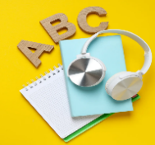
As a prerequisite for this activity, students need to know:
- all the food and drinks you will use
- there is/are
- right, left, below, above, besides, near or far.

- Split the students in two teams.
- Provide each team with pictures of food and drinks and tape or glue.
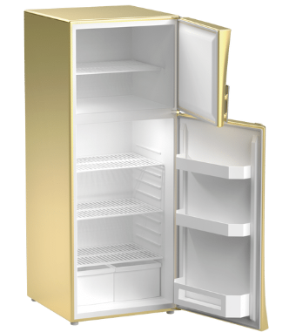
- Hang two large, printed images of refrigerators (at least A3 size) on the walls of the classroom or outside.
- Give students instructions on what and where place the food or the drink. In turn, one member of each team runs to the fridge and sticks the food or drink in their team's fridge according to the instructions. For example: there is a banana on the top shelf. There are two tomatoes under the banana. There is a chicken to the right of the banana. There is a bottle of water to the left of the tomatoes.
- The team that has correctly placed the food and drinks in the right place wins.

You can also modify the activity as follow:
- You can play the game without saying the position of the different food but only by saying which food and drinks are in the fridge.
- You can also ask the students to complete the activity at home using LearningApps (‘Group assignment’ section), using the images of the fridge and of the different food and drinks.

GAME 4 - Domino with food and drinks
- Together with students, create domino cards with food and drinks as in the example from A4 paper sheets.
- Ask students to stand in circle and give each of them four or five domino cards.
- Place on the ground a domino card – for example one with a banana and milk on it.
- In turn, students start placing the domino cards they have that match with the ones on the ground. For example, if a student has a domino card with a banana on it, they can attach it to the one on the ground, if they do not then they skip their turn.
- The game continues until a student runs out of domino cards. Whoever runs out of domino cards first wins.

When the students place the domino cards on the floor, they repeat the names of the foods or drinks. The teacher can also work on the expressions: I have it, I don’t have it.

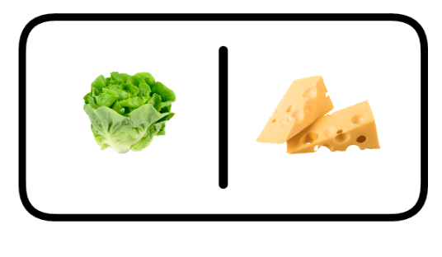
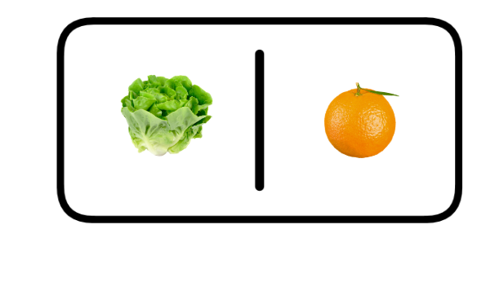
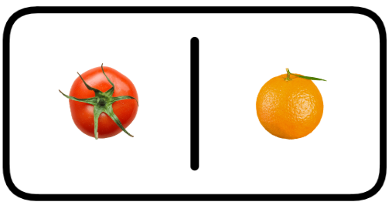
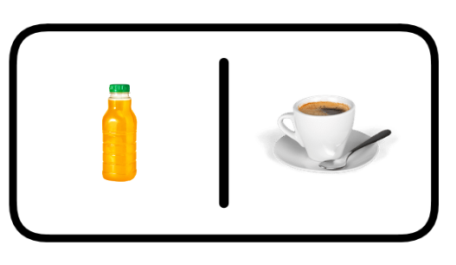
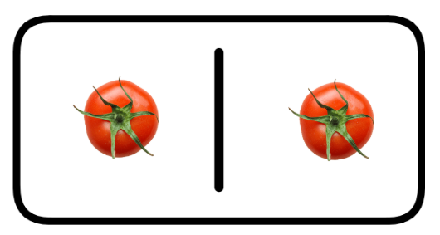

GAME 5 – Bingo with food and drinks
- Together with students, create bingo tables with all the food and drinks from Activity 1 of the Toolkit, as in the example below. Also prepare a bag with cards picturing the same items present in the bingo tables.
- Give students a bingo card each.
- Start drawing one card at the time from the bag and say aloud the item on it.
- Students who have that food or drink deletes it with a cross (X) from their bingo table.
- The student who finishes first wins the game. They must repeat the names of the food and drinks on their bingo table to ensure they are correct.

You can also design this activity as an homework using LearningApps, or Wordwall.

 |  | 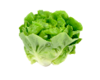
 |  | 

GAME 6 – Eating in the world
- Print the pictures below (or similar ones).
- Ask students to look at these places where you can eat. Guide the conversation by saying: Where do you like to each? Where do you not like to eat? Do you know the names of the objects in the photos?
Guide the students to expand linguistically with following questions: Imagine a table set for a meal—what items do you see? Perhaps plates, bowls, glasses, or even chopsticks or forks. Can you think of foods eaten with hands or those requiring cutlery? Which do you prefer, and why? In this country, tables might include specific arrangements—have you noticed anything interesting? Do not make explicit reference to the students' countries of origin but leave room for cross-cultural reflection.

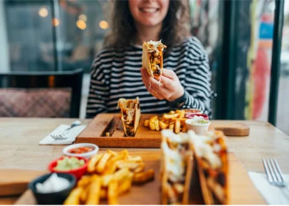 | 
 | 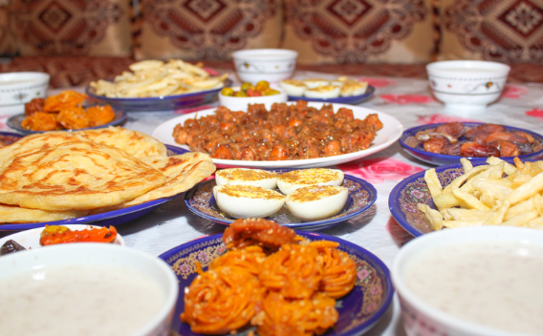


GAME 7 – Hosting a party
As a prerequisite for this activity, students need to know:
- names of the different meals (e.g.: lunch, dinner, snack)
- the times of the day
- locations and places

- Split the students into groups.
- Each group must think about organising a lunch. Each group has to decide:
    - The place: e.g. a park for a picnic to eat on the ground, a friend's house to eat on the table or sofa while watching a film, a living room at home to eat on carpets and cushions.
    - What to eat.
    - What to drink.
    - What time is lunch served?
- Together they need to prepare a lunch invitation using the sentences in the image below. To help them, write on a board other sentences they might need to complete the activity.


GAME 8 – Use your 5 senses!
Before starting the activities, consider the following:
- Be Mindful of Allergies and Dietary Restrictions: Check with students and their families beforehand to ensure that all food used is safe and inclusive for everyone. Clearly label all ingredients and avoid common allergens if possible.
- Prioritize Reusable or Compostable Materials: Use reusable plates, cups, and cutlery to minimize waste. If disposables are necessary, opt for compostable or biodegradable options.
- Encourage Respect for Food: Emphasize the importance of not wasting food by using small portions and incorporating leftovers into other activities or meals when possible.
- Ensure Cleanliness and Safety: Keep food handling areas clean, wash hands before the activity, and store food at the proper temperature to maintain hygiene.

- Split students into teams and guide them in the different steps of the game.
- At each stage of the game, students will have to take turns answering a question or guessing the food or drink. The team that guesses first and provides correct answers wins.


- STEP 1: Ask students to close their eyes and sniff coffee and guess what it is. You can guide them asking questions as: Is it tea? do you think it is orange juice?

- STEP 2: Ask students to close their eyes and listen to different sounds. You can shake water in a plastic bottle or rice in a container. Ask them to guess what it is.

- STEP 3: Ask students to close their eyes and make them taste some salt and sugar and guess what it is.
- STEP 4: Ask students to close their eyes and touch a banana, an orange, a tomato or an apple and have to guess which food it is.

- STEP 5: Students with their eyes open look at a food and guess the name. For example, yoghurt, aubergine, pasta. In this case you can vary the foods and present the most difficult ones to guess.

GAME 9 – The pizza recipe
- Show students the picture below and ask them to put them in the correct order. Put the recipe in order.
- Ask students if they have ever eaten pizza, which version they prefer, and with which ingredients. Always ask students also to name words and ingredients in other known languages. This may help in memorising vocabulary or other language structures.
A2 students can write the recipe and can put not only pictures but also sentences in order.
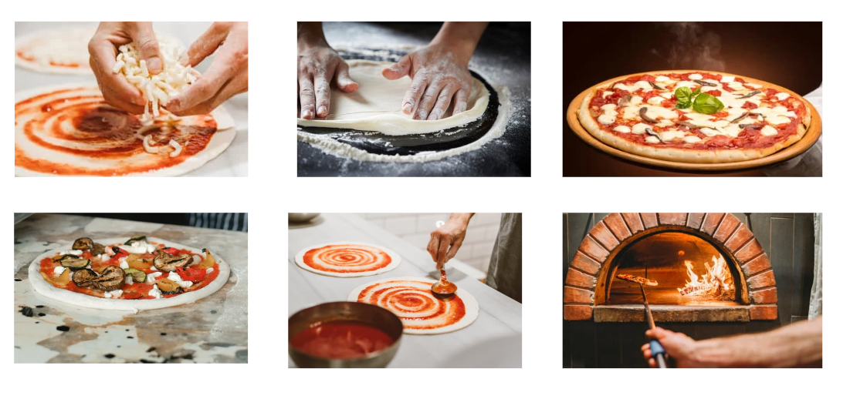

Linguistic domain 3 – At school

ACTIVITY 1 – Visual memory: what’s missing?
Version 1:
- Split the students into small groups.
- Show them a photo, like the one you see below, then show a second, identical photo, where an object is missing. The students have to guess what is missing.
Version 2:
- Arrange on a table objects students use at school, including a book and an exercise book.
- In turn, each student goes out of the room after looking carefully at what is on the table.
- The other students decide what to remove, for example the scissors (see photo below).
- When the student comes back, they have to guess what object is missing.
- You can make the activity increasingly challenging, progressively removing more objects.
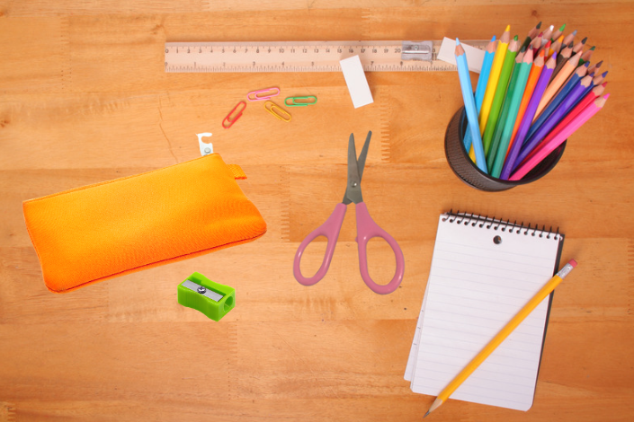
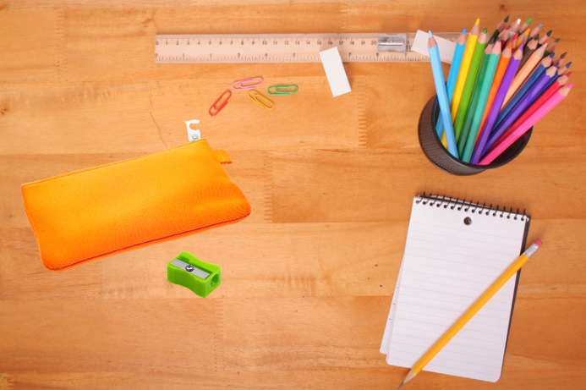

ACTIVITY 2 – The handkerchief game
- Split students into two groups, facing each other. Assign a number to each player.
- Hold a large container with objects students use at school (e.g.: a backpack, a red marker and a green marker, an eraser, glue, etc.).
- Say the name of an object and then the number. The people corresponding to the number called in the two teams run to retrieve the named object.
- The winner is whoever can manage to pick up the object and return to their team without being touched by their opponent.
ACTIVITY 3 – Let’s play
- The students are divided into pairs.
- Each pair has a Yussuf’s school timetable with some missing information. The pairs have to guess when Yussuf has art class. Answer: art class is on Friday between 8:30 and 9:30 am.
- Student A has a sheet with some information and student B has a sheet with different information. To complete the timetable and know on which day and time Yussuf has art class. Student A and B need to communicate and listen to each other to guess it right.
- The pair that fills in the timetable with the correct information first wins.
Timetable for students:
Yussuf’s timetable
Time | Monday | Tuesday | Wednesday | Thursday | Friday
8:30-9:30 | ENGLISH | WRITING |  | FRENCH
9:30-10:30 | HISTORY
10:30-10:45 | BREAK
10:45-11:45 | GEOGRAPHY | PHYSICAL EDUCATION
11:45-12:45 | READING |  | MATHS |  | FRENCH

Information for student A
- On Fridays after the break there is English
- English is studied 3 times a week
- Physical education is in the last hour on Thursday
- Tuesdays end with Maths
- On Thursday between French and Maths there is writing
- Art education is studied once a week only
Information for student B
- On Fridays before the break is geography
- English is studied on Wednesdays between first and third hour
- On Thursdays before Physical Education there is Maths
- Wednesday starts with English
- On Tuesdays before Physical Education there is Reading
- On Wednesday after the break there is French

ACTIVITY 4 – Communicative reading
- Split the students into teams and give them a bank sheet of paper to write on.
- For each group, prepare and write simple texts on a sheet of paper. Hang the prepared texts on a wall.
- In turn, each student runs to read a sentence from the sheet of paper hanging on the wall, comes back, tells the team what they remember, and they write together on the paper. The teacher sets a time limit for the groups to go and return from the wall. When the time runs out, the group that has completed the most text correctly wins.
You can also modify the activity as follows:
- Hang a picture on the wall. The students who have more linguistic competencies, can run, look at the picture, return and explain to the group what they have seen. The group draws what is being communicated.
- If students do not have adequate linguistic competencies, they can observe the picture, return to the group and draw what is on the sheet.

ACTIVITY 5 – Find the intruder
- Prepare tables as follow: each table should contain different objects – three similar to each other and an intruder.
- For each table, students should guess which object is an intruder.
A2 students have to explain why the object they selected is an intruder.

PEN   | APPLE   | RUBBER   | PENCIL  

NOTEBOOK   | BOOK   | PENCIL | ORANGE  

NOTEBOOK | PEN | MILK   | BOOK
CANTEEN   | CLASSROOM   | PAPER   | ENTRANCE  

Linguistic domain 4 – Clothes and accessories

GAME 1 - Dressing up for an event
- Bring some fashion or supermarket magazines into the classroom
- Prepare several coloured flashcards, containing information as follows:
  - orange flashcards: location (e.g. park, cinema, end of Ramadan party, New Year's Eve party, end of language course party, language exam, birthday party, etc.). You can add as many locations and types of parties as you want. You can add whether it is hot or cold, summer or winter or leave it up to the students to choose when and where the event will take place.
  - pink flashcards: people (e.g. Samia, 13 years old, José, 15 years old, etc.). Adapt the cards for events and people according to the age of the students you are working with.
  - blue flashcards: clothes and accessories (e.g. trousers, scarf, slippers, T-shirt, hijab, belt, earrings, shoes, socks, etc.).
- Split the students into group of 2 or 3 people.
- Each group takes 1 orange card, 1 pink card and 1 blue card. Depending on what is on each card, the group can describe or write who the person is, where they go and how they will dress. Then they have to explain if they have all the necessary clothes or accessories or if any are missing. For example, if they have a party in the park but only have fancy clothing, students can say: we don't have tennis shoes, we don't have jeans, etc.
- Below you can find some examples but remember that in each orange card there will be a place, in each pink card there will be a person and in each blue card clothes and accessories.
Orange flashcards  Park - summer  Cinema - winter  New Year’s Eve party  Birthday party | Pink flashcards  Samia, 13 years old  Yussuf, 16 years old  Marta, 12 years old  Mirda, 17 years old | Blue flashcards  Trousers and pink shoes  Hijab, shirt, flip-flops  Belt, earrings, socks.  Scarf, pullover.

GAME 2 – Guess the word
- Visit LearningApps to create an interactive activity and select the picture-word matching option.
- Upload a picture (e.g., a shop, classroom, or park scene); add symbols (e.g., red dots) to the picture, each corresponding to an item or word (e.g., bag, hat, pencil, etc.) and provide multiple-choice answers for each symbol so students can match words to the image.
- As an example, you can enter the example activity below following the link or by scanning the QRcode. You will see a picture of a shop with a shop assistant and a person who wants to buy some clothes. You can click on the four dots close to each item and choose the right word. You can also create the activity for free by choosing age-appropriate pictures that contain words that your students have worked on. The activity remains private and visible only to those who have the link or QRcode. Make sure you choose the option ‘private’ and not ‘public’ at the end of the activity.
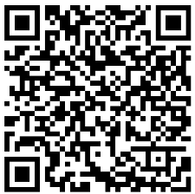
https://learningapps.org/watch?v=p8bg7cghj24

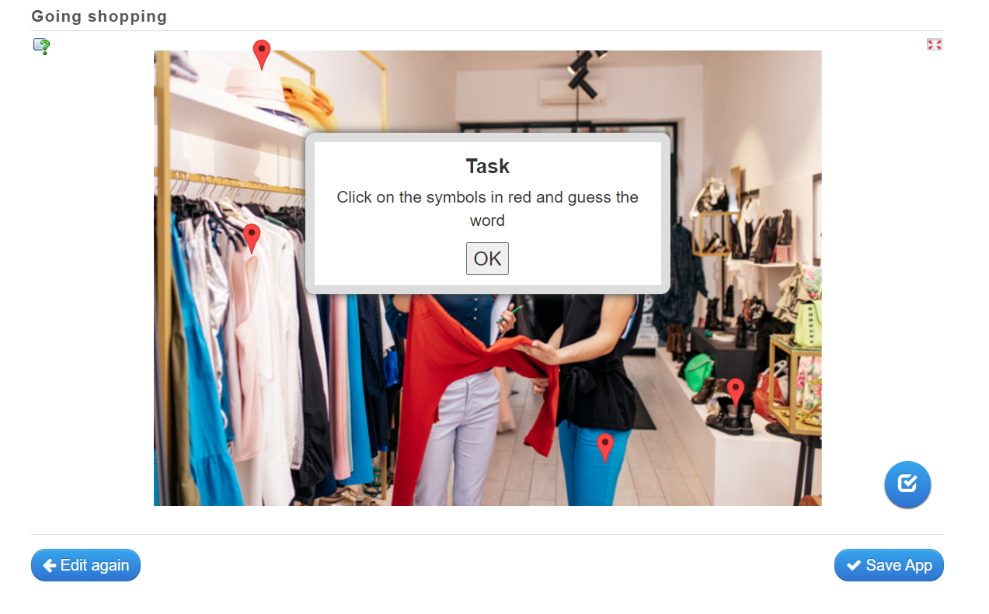


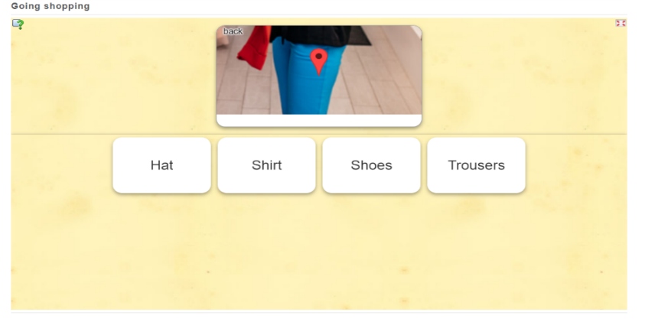

GAME 3 – Guess the object or the dress
- Choose a set of words related to clothes or accessories (e.g., hat, belt, trousers).
- Select a list of people familiar to the students (the teacher, a classmate, an educator, or characters from teaching materials
- Write each name on a post-it note. To support beginner students, you can write the chosen names of people, clothes, and accessories on the blackboard.
- Split students into small groups or play as a class.
- Each student takes a turn picking a post-it note and placing it on their forehead without reading the word.
- The student then asks questions to guess the word on their post-it, such as:
  - “Is it a person?”
  - “Is it a piece of clothing?”
  - “Is it someone I know?”
  - “Is it an accessory?”
- For more advanced students, peers answer only with "yes" or "no."
- For beginner levels (e.g., PreA1 or A1), you can give hints or provide full-sentence answers to make the exercise easier.

GAME 4 – Let's play with art! (1)
- Create your own blackboard on Padlet using the painting you see in the image below. This option allows you to play with art.
- Ask the students if they know the painting. First show it in black and white. Ask them what colour objects they see and to name each object. Say and/or write: Georges Seurat is an artist, and he is the painter of: A Sunday Afternoon on La Grande Jatte. It was painted in 1884. You can find it at the Metropolitan Museum of Art of New York, USA.
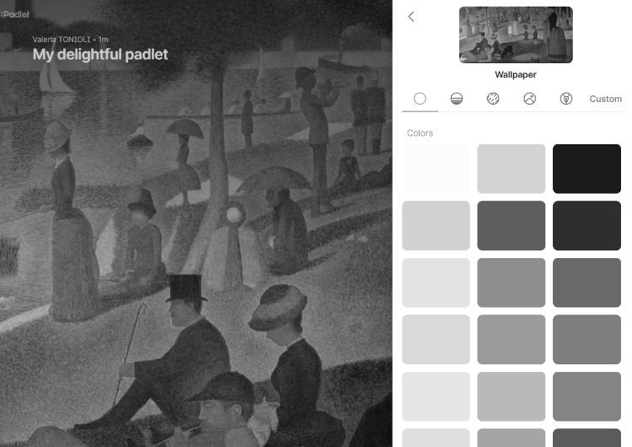
- Then ask students to look in the painting for clothes and accessories they already know like: ORANGE CLOTHES, UMBRELLA, HAT.

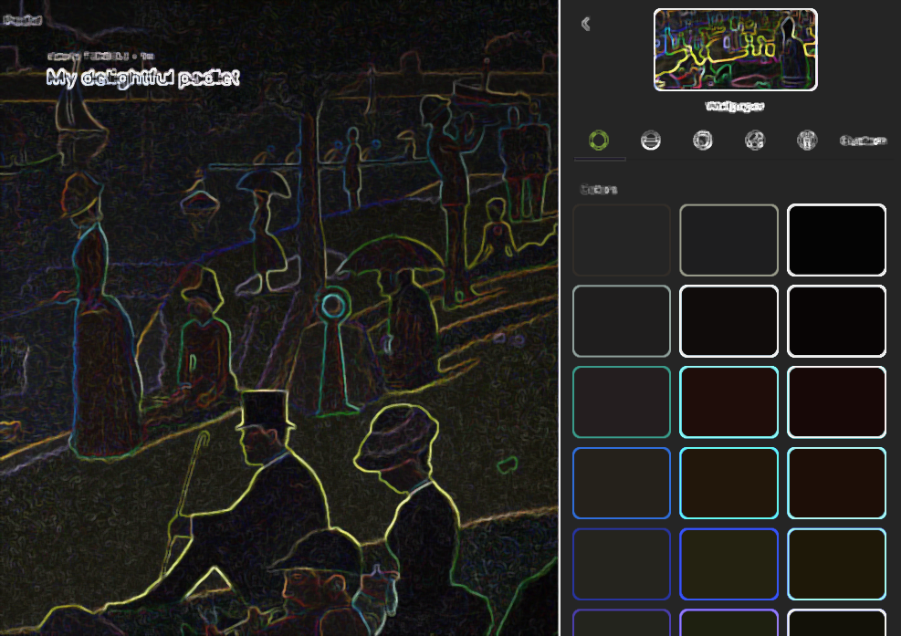
Another possibility is to play with the painting and reproduce it digitally in different versions. You can do it in Word by clicking on the image and select artistic effects. You can ask the students whether they like it more or less and why and what changes.

GAME 4 – Let's play with art! (2)
- Print the images below. They represent the island of Île de la Jatte in France, near Paris where they can find the painting in the game above.
- Ask the students: Do you know where Paris is? Have you ever visited Paris?
- Provide the students with tablets or smartphones or they can use their own mobile devices and ask them to search the location on Google Maps. Ask them: What do they see? Is the painting similar to the Google Maps images? Is it different? Are there people in the place that you can see with Google Earth? Are they dressed like in the picture or are they different?
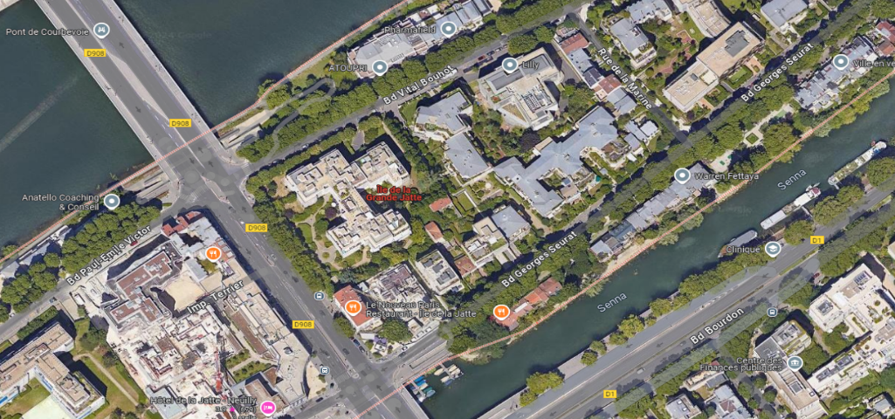
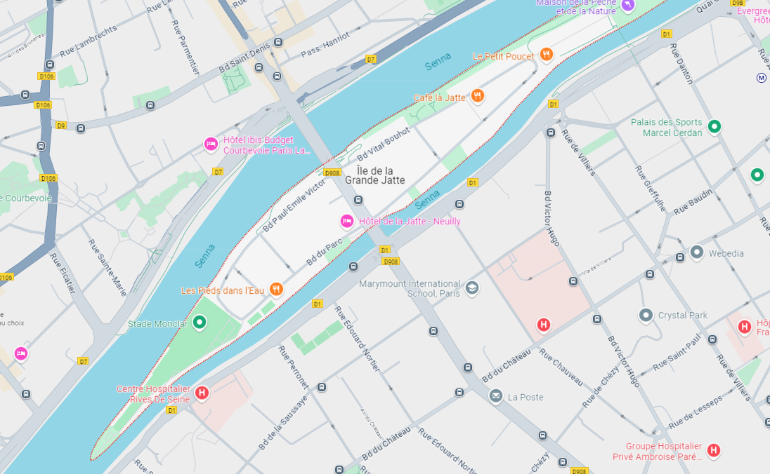

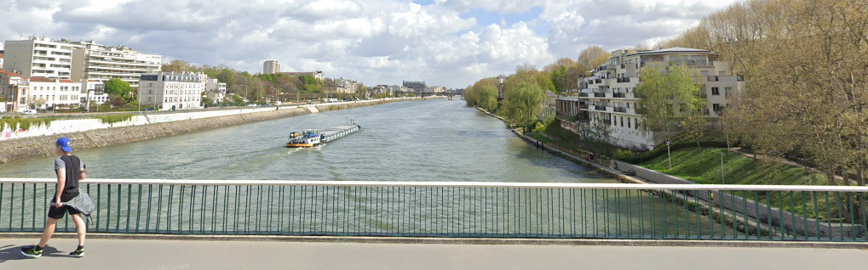

- Then ask the students: Do you know any other places similar to this near the river? Are there similar places near to where you go to school or where you live?
- You can then look for other paintings representing existing objects or places by different artists, contemporary or from other years. As in the previous exercise, ask the students to look for the places represented or to reconstruct them in class. Imagine, for example, a painting depicting a man writing on a table, dressed in a black jacket, a large hat, etc. Students can work in pairs or teams to recreate what is seen in the painting and describe it, either in writing or verbally. For example, the following painting can be observed, described and reproduced. Some students can make a full description, others recognise colours, foods or objects. Students can also repaint with different colours, different foods or recreate the painting with some modifications and then explain the different choices to the class.
- As in the previous activity, you can investigate where the painting is located and ask the students if they know the place, if they like it.
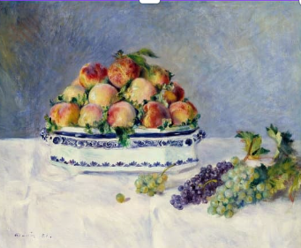
Still Life with Peaches and Grapes
Pierre Auguste Renoir, 1881

You can also modify the activity as follows:
- You can search for museums close to the school or education centre where you work. You can go there and ask, for example, to look for all paintings in which there are women dressed in long skirts or men wearing hats.
- At school, the activity can involve several teachers, not only the L2 expert but also the art teacher, literature teacher or other professionals such as a photographer or artist. The activity can also be part of a civic education course at the end of which through a painting, a mural, a drawing students can convey a message for society, the neighbourhood or the school using different languages.
- The activity opens up the possibility of working on how fashion has changed over the years, depending on the interests of the class. It is possible to look at different items of clothing, from one country or several countries, and place them on a timeline in chronological order.

Linguistic domain 5 – Health and emotions

GAME 1 - Mentimeter: the word HEALTH
- Discuss with students the meaning of the word HEALTH. You can create a Word cloud using the free version of the App Mentimeter.
- Once you register and create your Word cloud, share the link to the Word cloud with your students and see their answers.
- Ask the class, in general, why they entered those words, whether they agree or disagree. Remember that they can also use other words in different languages
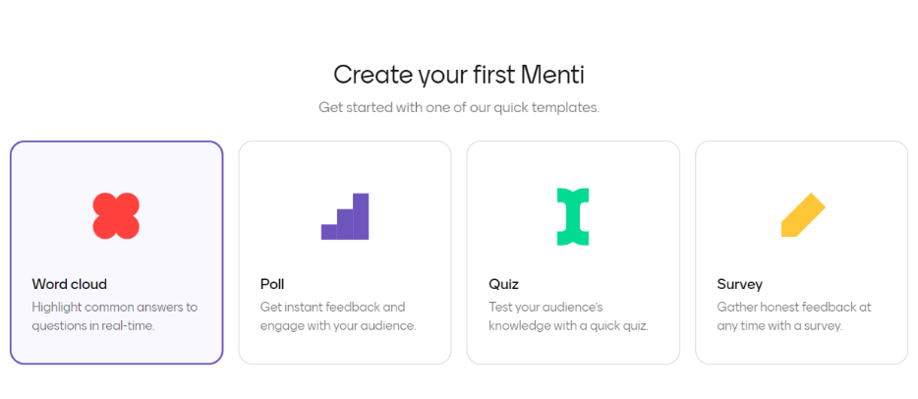

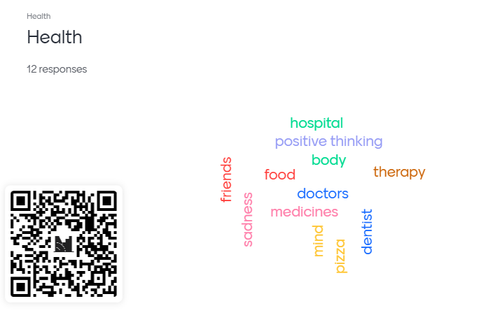

GAME 2 - Role play: doctor, disease, medicine

- Create cards of different colours into which you place medicines, doctors and diseases, as follows:
  - On the red cards you can write names of diseases or ailments such as cold, headache, stomach-ache, toothache, flu, allergy, menstrual cycle, nausea, etc.
  - On the brown cards you can write names of medical specialists such as paediatricians, gynaecologists, dentists, opticians, general practitioners, etc.
  - On the purple cards you can write names of possible medicines or natural remedies such as tablets, syrup, honey, ginger, hot water bottle.
- Split the students into groups of 3 or 2.
- Give each group 3 cards to create a role play. Give examples of linguistic formulas to be used in the role play, e.g. ‘I am sick, I need medicine, I have ...’, ‘How many times a day should I take the medicine?’, etc.

GAME 3 - Tips for a friend
- Split the students into pairs.
- Provide each pair with the following scenario: “Your friend Samir sent you a message. He has a cough, sore throat, and a cold today. He has already visited the doctor and is taking medicine but wants to know if there’s anything else he can do to recover faster. Can you give him advice?”
- Each pair writes a response to Samir’s message on a sheet of paper.
- Encourage students to give advice such as:
  - “You can drink warm water with honey and ginger.”
  - “You should rest, sleep well, and listen to relaxing music.”
- The activity is anonymous—students should not write their names on the paper. Once completed, pairs fold their sheets and hand them to the teacher.
- Read out all the advice to the class.
- On the blackboard, the teacher tallies which suggestions were most frequently mentioned.
Remember that students must know the names of the foods and drinks and must have already worked on some everyday actions such as sleeping, resting, reading, listening to music

Linguistic domain 5 – City, neighbourhood and leisure time

GAME 1 –Guess the items of the box
- Using Wordwall or other free online apps, prepare four/five boxes corresponding to rooms of the house.
- Show the students the different boxes and ask them to open one.
- Once the box has been opened, ask the students to guess the words they know related to that particular room. If they do not know any word, explain and provide them with the necessary vocabulary and show them how they are spelled.
- Together guide them in creating a multilingual glossary for the different rooms of the house.
- You can find the activity as an example at the following link: https://wordwall.net/it/resource/83860246
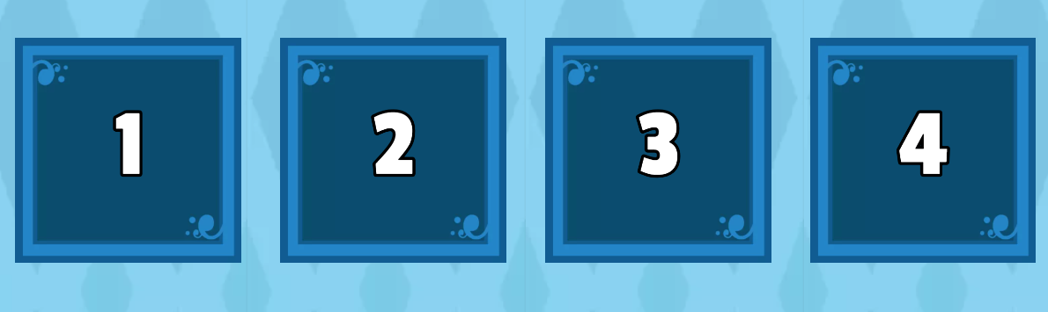

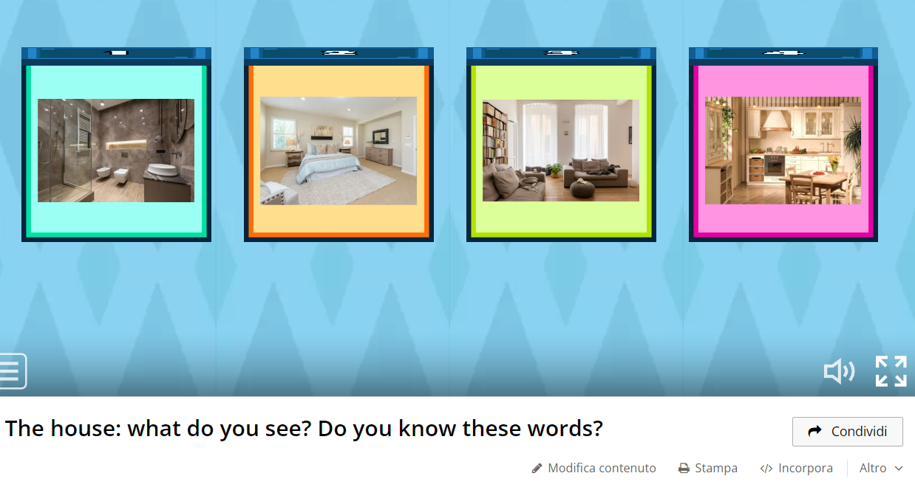

GAME 2 –Match words and images in the city
- Using Wordwall or other free online apps, choose one or different pictures of a location or a landscape and choose some words such as window, building, street, street market, etc.
- Ask students to match the correct word to the white dots in the picture. you can set up a vocabulary activity where students have to match words to white dots on a picture or image.
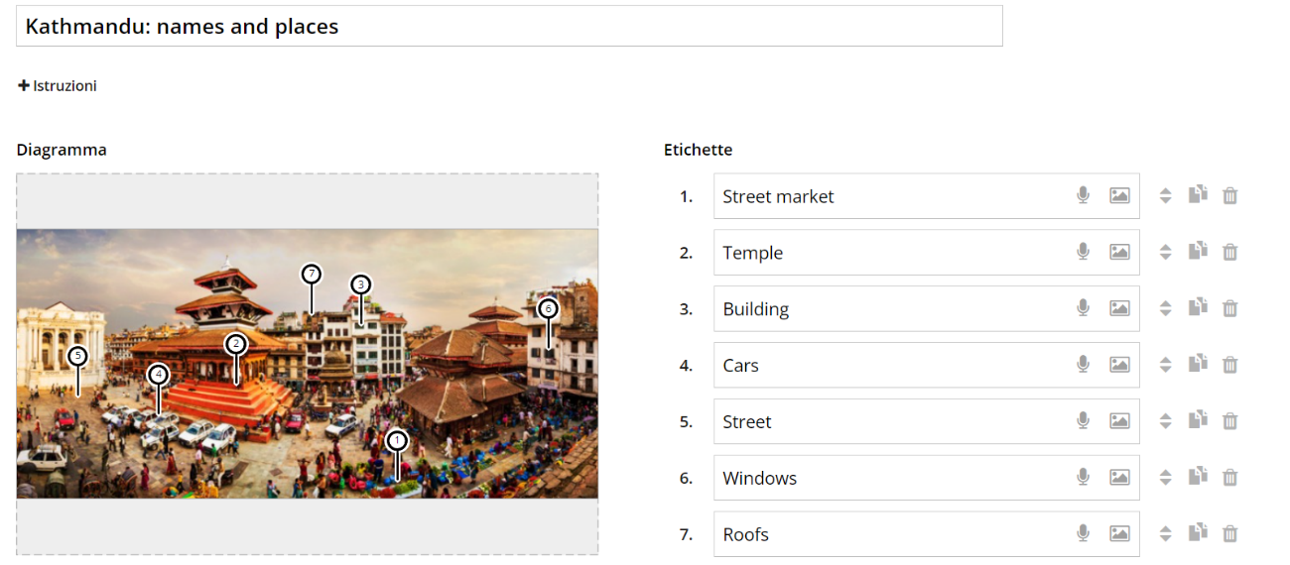
- You can find the activity as an example at the following link: https://wordwall.net/it/resource/83859870

The picture should be useful for teaching purposes and include words you’re your students know and are useful for them.

GAME 3 – Plurilingual landscape

What are plurilingual landscapes?
To answer this question and to learn more about the potential and importance of the use of multilingual landscapes in education, we recommend reading the article written by Lisa Marie Brinkmann, Joana Duarte and Sílvia Melo-Pfeifer in 2022 and available at the following link:
https://teslcanadajournal.ca/index.php/tesl/article/view/1475/1313
Within the article, the writers also mention other authors who define plurilingual landscapes as:
“The language on public road signs, advertising billboards, street names, place names, commercial shop signs and public signs on government buildings [that] combine to form the LL of a given territory, region, or urban agglomeration” (Landry & Bourhis, 1997, p. 25).
The importance of making linguistic and cultural heritage visible is also mentioned in the article:
“Language use on signage in public spaces influences the visibility of languages and can be both a marker of and a contributor to the ethnolinguistic vitality of a language” (Kuipers-Zandberg & Kircher, 2020).

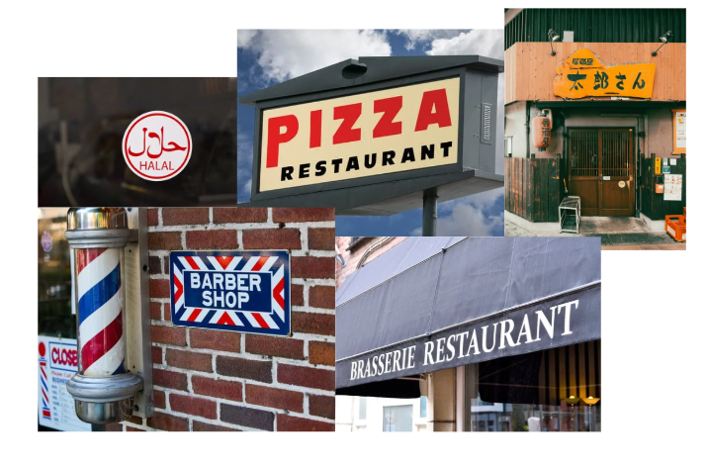
- Select images that testify to a plurilingual landscape of a multicultural and multilingual neighbourhood as in the example below. Use pictures of your city or area to make the activity more meaningful and motivating for the students.
- Ask the students if they know the languages of the images and explain them what are plurilingual landscapes.
- Provide students with tablets, smartphones or devices, either personal or from the school or education centre that allow them to take photos in the city and witness the plurilingual landscape.
- Guide the students outside of the classroom and ask them the following questions:
  - Which areas of the city do you like best? Why?
  - What do you normally do in those areas?
  - What are the languages present in these areas? Do you think there are languages missing?
- Ask them to take note of which languages they see the most and ask if and what they would like to change.
You can also modify the activity as follows:
- The activity can also include murals, graffiti and urban art in your reflection. Ask students the following questions: What language is it in? Is the non-verbal dimension used? Do you like them? In which other languages and/or with which other images would you modify them?
- The activity can also include a visit to the neighbourhood library to see which books are present and in which languages. Ask students the following questions: What would you like in the library? Some libraries also have a media library and a game room. What languages are they in? What would you like to read or do?

GAME 4 – Plurilingual Podcast
- Using the free version of Padlet, create a podcast with your students on the story of the city, the area, the neighbourhood or the school, from the students' point of view.
- You can divide the students into working groups, accompany them to places in the city where they can take photos, videos or collect material they need and help them to transfer what they have collected into a text, an audio or video file. They can tell little stories or describe an itinerary, how a service works, depending on their age, needs, interests and language level.
- Do not force students to use their mother tongue but guide them to choose one or more languages that they like and that are available to them.
- You can find the activity as an example at the following link: https://padlet.com/valeriatonioli/podcast-plurilingual-cities-fsqj7yqvhhaqy93s.
- Guide the students to interact with the podcast that have already created asking the following questions: Can you guess the languages used in this podcast? Do you know the places mentioned?

References

Michel Candelier, M., Camilleri-Grima, A., Castellotti, V., De Pietro J., F., Lőrincz, I., Meißner, F., J., Noguerol, A., Schröder-Sura, A. (2012). FREPA A Framework of Reference for Pluralistic Approaches to Languages and Cultures Competences and resources. Graz, European Centre for Modern Languages / Council of Europe. https://www.ecml.at/portals/1/documents/ecml-resources/carap-en.pdf

Council of Europe. (2020). COMMON EUROPEAN FRAMEWORK OF REFERENCE FOR LANGUAGES: LEARNING, TEACHING, ASSESSMENT. Companion volume.
https://rm.coe.int/common-european-framework-of-reference-for-languages-learning-teaching/16809ea0d4

Cummins, J. (1980). Psychological assessment of immigrant children: Logic or intuition? Journal of Multilingual and Multicultural Development, 1, pp. 97-lll.

Cummins, J. (2008). BICS and CALP: Empirical and Theoretical Status of the Distinction. In: Hornberger, N.H. (eds) Encyclopaedia of Language and Education. Springer, Boston, MA. https://doi.org/10.1007/978-0-387-30424-3_36

Baker, C. (1996). Foundations of Bilingual Education and Bilingualism. 2nd ed. Clevedon, Multilingual Matters.

Bligh, A. C. (2014). The silent experiences of young bilingual learners: A sociocultural study into the silent period. Sense Publishers.

Brinkmann, L. M., Duarte, J., & Melo-Pfeifer, S. (2022). Promoting Plurilingualism Through Linguistic Landscapes: A Multi-Method and Multisite Study in Germany and the Netherlands. TESL Canada Journal, 38(2), 88–112.
https://doi.org/10.18806/tesl.v38i2.1358

Dörnyei, Z. (2001). Motivational Strategies in the Language Classroom. Cambridge, Cambridge University Press.

European Commission, Directorate-General for Education, Youth, Sport and Culture. (2016-2017). Rethinking language education and linguistic diversity in schools. Rethinking language education and linguistic diversity in schools - Publications Office of the EU

European Commission, Directorate-General for Education, Youth, Sport and Culture. (2019-2020). Education begins with language. Education begins with language - Publications Office of the EU

García, O., Wei, L. (2014). Translanguaging: Language, Bilingualism and Education. Palgrave Macmillan, Basingstoke, U.K.

Harmer, J. (2015). The practice of English Language Teaching- 1st edition. Pearson.

Krashen, S. (1981). Second language acquisition and second language learning. Toronto, Pergamon Press.

Vallejo, Rubinstein, C.; Tonioli, V. (2023). Exploring the Linguistic and Cultural Identities of Transnational Background Children in Catalonia, Spain. SOCIETIES, vol. 13 (ISSN 2075-4698), https://doi.org/10.3390/soc13100221

Webography

The New ABC project. Available at: https://newabc.eu/

The UNESCO website on mother tongue and plurilingual pedagogies is available at:
https://www.unesco.org/en/articles/why-mother-language-based-education-essential

The European Commission guidelines on Key Competences for Lifelong Learning are available at:
https://education.ec.europa.eu/focus-topics/improving-quality/key-competences

The European Commission guidelines on Literacy and Second Language Learning for the Linguistic Integration of Adult Migrants (LASLLIAM) are available at: Launch conference of the new reference guide LASLIAM - Linguistic Integration of Adult Migrants (LIAM)

The European Commission Bank of supplementary descriptors of the CEFR for Young Learners are available at: Bank of supplementary descriptors - Common European Framework of Reference for Languages (CEFR)

